
CONSTITUTIONAL COURT
SPECIAL APPEAL CHAMBER
Tirana, on 29.12.2025

ECONOMIC REPORT
Economic Advisor
Eni Karagjozi

CASE: (JR) No. 45/2022, dated 13/10/2022

APPELLANT: The assessee, against the Decision No. 542, dated 20.06.2022, of the Independent Qualification Commission, on the assessee Ms. Brunilda Çarçiu, Inspector at the High Judicial Council.

OBJECT OF APPEAL: 1. Adjudication of the case in a public hearing;
2. Finding of violations of constitutional rights and those provided for by the ECHR of the appellant Mrs. Brunilda Çarçiu, serving as Inspector at the Inspectorate of the former HCJ, now HJC;
3. Amendment of the Decision no. 543, dated 28.06.2022 and ruling as follows:
- To declare complete the transitional re-evaluation process for Mrs. Brunilda Çarçiu, without a final decision, as the object (the re-evaluation process) on which the procedure was initiated, has become impossible, because the appellant is not a vetting subject/ assessee.
- If the Appeal Chamber concludes that the appellant is an assessee, to rule for confirmation in office of Mrs. Brunilda Çarçiu, Inspector at the Inspectorate of the former HCJ, now HJC.

THE TRIAL PANEL OF THE SPECIAL APPEAL CHAMBER REVIEWING THE APPEAL:
Presiding Judge: Natasha Mulaj
Judge Rapporteur: Mimoza Tasi
Judges: Ina Rama, Rezarta Schuetz, Albana Shtylla

IMO REPRESENTATIVE: Mr. Ferdinando Buatier de Mongeot

Content

I. The Decision of the Independent Qualification Commission 2
II. Circumstances of the case 3
III. Grounds of the Appeal 4
IV. Regarding the appeal for the criterion of assets of the assessee, the Economic Advisor analyses the the ground of appeal as follows: 4
A. Regarding the two-storey house in co-ownership in Laprakë, Tirana, built until 2000; 4
B. Regarding the apartment 56 m2, L. 13, Plazh, Durrës and shop 52.32 m² in Rr. “4 Dëshmorët”, Tirana, acquired in 2007; 15
C. Regarding the proceeds from lease of 52.32 m2 unit, in Rr. “4 Dëshmorët”, Tirana; 20
D. Regarding the cash balance at the end of 2010 and on 03.03.3011; 23

Honourable Judges of the Special Appeal Chamber, (hereinafter the Chamber / AC) at the Constitutional Court, the Economic Advisor, having examined the case in its entirety, analyzed the case file of the assessee lodged with the Chamber by the Independent Qualification Commission (hereinafter the Commission / IQC), discussed with the Legal Advisor, and accomplished the tasks assigned by the Judge Rapporteur, in compliance with Article 20, para.4 of the Regulation “On the activity of the Special Appeal Chamber at the Constitutional Court “, as amended – has prepared the report as follows and:

NOTES:

The Decision of the Independent Qualification Commission
- The Independent Qualification Commission no. 542, dated 20.06.2022, decided by majority vote:
″1. To dismiss from office the assessee Brunilda Çarçiu, inspector at the Inspectorate of the former HCJ, now HJC […]″
The IQC Panel ruled according to the provision of Article 55 of Law no. 84/2016, based on Article 58/1/c and Article 61/3 of Law no. 84/2016, “On the transitional re-evaluation of judges and prosecutors in the Republic of Albania”.
- HIDAACI, by the “Report on completion of full audit of asset declaration of the assessee Brunilda Çarçiu” Prot. No. 606/33, dated 11.05.2018, found that: i. The declaration is not accurate as per the law; ii. There is lack of lawful financial resources to justify the assets; iii. The assessee has not concealed assets; iv. Has not made false declaration; v. Is not in any situation of conflict of interest.
- The Commission, based on the evidence available, concluded the re-evaluation of the assessee based on the three re-evaluation criteria. The IQC panel, after being acquainted with the circumstances of the case, based on the evidence administered and the evidence submitted by the assessee, concluded that:
- Referring to Article D of the Annex to the Constitution and Chapter IV of Law No. 84/2016, it resulted that the assessee Brunilda Çarçiu has not reached a reliable level in the evaluation of assets, according to Article 59/a of the law.;
- Referring to Article DH of the Annex to the Constitution and Chapter V of Law No. 84/2016, the assessee Brunilda Çarçiu has reached a reliable level for the background assessment, according to Article 59/b of the law;
- Referring to Article E of the Annex to the Constitution and Chapter VI of Law No. 84/2016, the assessee Brunilda Çarçiu has reached a qualifying score in the assessment of professional competence, according to Article 59/c of ​​the law.
The decision-making on the assessee was based on the conclusions reached for the asset criterion as follows:
“83. At the end of the asset assessment process, it was confirmed that the assessee Brunilda Çarçiu lacks lawful financial resources to justify the assets and expenses during the entire re-evaluation period, due to the negative balance in the amount of ALL 4,824,260, of which ALL 1,155,914 belongs to the period outside of term in office, and 3,668,345 ALL belongs to the term in office.
As for the negative balance, in the period outside the term in office, referring to the standard held in similar cases by both the Commission and the Chamber, the Commission, based on the factual circumstances of this balance, as well as the value, considered that proportionally this negative balance cannot penalize the assessee. This is also in consideration of the fact that although some assets in the form of liquidity declared by the assessee's spouse in this period – also carried over to the Vetting declaration - are unjustified with lawful resources, these liquidities were not proven to have been invested for the creation of any assets during the term in office. Meanwhile, according to the criteria set out in law no. 84/2016, para. 5/d, article 33, para. 3, article D of the Annex to the Constitution, as well as based on the standard already established regarding the value of the penalizing negative balance for the assessee, at the end of the process the Commission noted that the negative balance of ALL 3,668,345 for the term in office constitutes a reason for taking the disciplinary measure of dismissal of the assessee from office.”;
- The rapporteur of the case at the IQC, Firdes Shuli, had a concurring opinion, different from the other two members of the panel, she was of the opinion that Ms. Brunilda Çarçiu is not a vetting subject / assessee, she was not one of the subjects mentioned specifically in Article 179/b of the Constitution, at the moment of the entry into force of the constitutional amendments, her re-evaluation, according to the criteria of Law No. 84/2016, being treated equally with other assessees, has aggravated her position, leading to her dismissal from office, which brings as a consequence the 15-year ban from exercising duties in justice bodies, a consequence which would not come in case of termination of the process without a final decision, according to Article 95 of the Administrative Procedure Code.

Circumstances of the case
- The assessee Brunilda Çarçiu, after completing her studies in 1991, was appointed a judge at the Gramsh Judicial District Court, wherefrom she left, upon her request, in May 2000; from May 2000 to March 2011, she was a legal assistant at the High Court; by order of the HCJ no. 6 dated 09.05.2012, she was appointed a specialist at the HCJ Inspectorate; by decision no. 129, dated 18.11.2016, of the HCJ, she was appointed an inspector at the HCJ Inspectorate.
- The assessee filed an appeal [prot. no. 2409/4, dated 30.08.2022], against the IQC Decision, whereby she disputes in connection with the status of the appellant, procedural issues and with regard to the re-evaluation of assets, referring to the conclusions of the Commission.

Grounds of the Appeal
The issues of appeal are elaborated in the report of the legal advisor as well as in the analysis of the grounds of appeal below. In the appeal, the assessee has submitted in a summary, the grounds of appeal regarding the asset assessment criterion and the assets as follows:
    - Re. the two-storey house in co-ownership in Laprakë, Tirana, built until 2000;
    - Re. the apartment 56 m2, L. 13, Plazh, Durrës and shop 52.32 m2 in Rr. “4 Dëshmorët”, Tirana, acquired in 2007;
    - Re. the proceeds from lease of 52.32 m² unit, in Rr. “4 Dëshmorët”, Tirana;
    - Re. the cash balance at the end of 2010 and on 03.03.3011;
    - Re. the “Mecedes Benz” vehicle, purchased on 29.05.2010;
    - Re. the “Renault” vehicle, purchased on 06.11.2010;
    - Re. the final financial analysis of the total period.

IV. Regarding the appeal for the criterion of assets of the assessee, the Economic Advisor analyses the ground of appeal as follows:

A. Regarding the two-storey house in co-ownership in Laprakë, Tirana, built until 2000;

In the Vetting Declaration, [the assessee] stated: “Two-storey house in co-ownership, respective share 1/4, located in Laprakë, built by the family, bit by bit, since 1996, valued according to the prices of the time, legalized by legalization permit, no. 89618 dated 19.12.2014, with a plot of land area of ​​568.4 m², construction area of ​​243.9 m², according to the certificate ownership with serial no. 1172939, cadastral zone no. 8310, property no. 6/1191 and attached documents. Value ALL 3,000,000. 50% co-ownership with the spouse of the 25% share. Source: Savings from salaries over the years and income from private activity.

In the PAD 2003 she declared: “2-storey house. Construction started at the end of 1996. Pandi Dardha Street, Laprakë. Unregistered. Value ALL 3,000,000.” Source: Income from private small business activity in Gramsh. Family income.

In the Declaration Before Assuming Office 18.11.2016 she declared: “Two-storey house, area of 150m² in Laprakë, built in 1996-2000, legalized by decision no. 89618 dated 19.12.2014. Value of ALL 3.000.000.” Source: Savings from salaries over the years and income from private activity.

The Commission concluded in its decision on this asset (page 19 - 22 of the decision):
- “42. […] In conclusion, the Commission considered the period 1997 – 2000 as the construction period, as the assessee claimed. As for the value of the investments, the Commission assessed that, although the value according to the NHE prices is lower than ALL 3,000,000, the assessee has carried out works at costs higher than these prices and in the final assessment, it considered the amount of ALL 3,000,000 as the investment value, referring to the following facts and circumstances: (i) there is a lack of technical-legal documentation to show the value of the investments; (ii) the assessee has consistently declared the amount of ALL 3,000,000 as the value of the property, starting with the declaration for the year 2003, continuing with the declaration for the year 2016 and the Vetting declaration; (iii) the assessee's husband before HIDAACI as per the minutes dated 7.2.2017, stated that the value spent for his share was ALL 3,000,000; (iv) the assessee's claim that he referred to the market value is not valid, as the market value was twice higher than the value of ALL 3,000,000..”
- “43.1 […] In the analysis of the evidence administered throughout the administrative investigation, at the end of the process, since the Elbasan Regional Tax Directorate relates the lack of documentation to the events of 1997, based on Article 32/4 of Law No. 84/2016, the Commission found that the assessee is under conditions of objective impossibility to prove concrete income from the father-in-law's activity during the years 1993 − 1997. However, it does not find this claim founded on any evidence or document, for the years 1998 and 1999. For this reason, the Commission deems it appropriate to consider in the financial analysis for the construction of the house, the amount of ALL 393,336, which consists of the minimum wage determined according to the Decisions of the Council of Ministers of the years 1993 − 1997.”
- “43.2 [...] At the end of the process, regarding the husband's income as an accounting expert, the Commission concluded that this income could not be considered as lawful income for 1997, based on the following circumstances: i) it was not proven whether the assessee's husband has audited 18 commercial entities and, moreover, has received payment from such audit. The assessee's calculation of the remuneration received by her husband shows the amount of income that should have been received, but does not prove the receipt; ii) being a public official, her husband was not registered, as he could register as a commercial entity/liberal profession with the tax authorities to exercise the profession of accounting expert; iii) if it were to be assumed that this income was received, despite the fact that it is atypical, withholding tax should have been paid on it based on tax legislation. The payment of the withholding tax cannot be presumed to have been made because the assignment was ordered by the tax authority, moreover, since the assessee has neither claimed nor provided any explanation as to whether this payment has been made and when; iv) the assessee has not proven being under conditions of objective impossibility, since the confirmation issued by the Gramsh RTD that this directorate does not have any data, without providing any reason for it, is closer to the description of the real situation of Mr. Arben Çarçiu, that he was not registered with the tax authorities, since he could not be registered because he was an official of the state administration.”
- “43.4. Regarding income from agriculture, [...] In this case, the Commission estimated that living expenses would be reduced from 66% of the household income to 30% of it”;
- “44. At the end of the process, based on the above, the Commission revised the financial analysis to justify the investment of ALL 3,000,000, which changed from -ALL 2,543,177 sent with the results of the investigation, to a balance of - ALL 206,928. This difference came as a result of considering the construction period extending from 1997 to the end of 2000, which led to the inclusion of the assessee's household income for the period after March 1997 (construction period considered in the report on the results of investigation) and the inclusion of the income of the father-in-law and mother-in-law documented with the assessee's submissions.”

The assessee stated in the appeal regarding this property:
- She disputes the Commission's conclusion for a negative balance of ALL 206,928 to justify the investment for the construction of the house. The assessee claims that the cost of the house, built until the end of 2000, is ALL 1,727,494, according to the construction cost determined by the NHE, by deducting the value of cost items that are not carried out in informal constructions. She also claims that the Commission has not considered her statement in the Vetting Declaration “valued according to the price of the time” which shows that she declared the price that she thought the asset was worth at the time of the declaration and not the cost of construction, the value of the asset at the time of creation.
- Regarding the sources declared for the creation of this asset, she request the inclusion in financial analysis of a) the income from the private activity of the father-in-law Rexhep Çarçiu, for the period 1993-1999, which should be calculated at least at the value of ALL 606,720 and not as considered by the Commission of ALL 393,336, which did not consider the years 1998 and 1999 as reasoned in the decision [paragraph 43.1] and b) requests that the value of ALL 630,000, received in 1997 from the husband's activity as an authorized accounting expert, be considered as lawful income and be included in the financial analysis.
- She disputes the calculation by the Commission of living expenses for the period up to 1999, as according to her these expenses were lower because part of the family expenses was covered by the products obtained from the use of agricultural land owned by her father-in-law. The assessee claims that the Commission recognised the reduction of the living expenses for the period by 30% of the income due to the high income and does not accept the reduction as a result of agricultural and livestock products, and that each of the reductions comes for different reasons accepted by the Chamber and that the expenses should be reduced by 40% due to the use of agricultural and livestock products produced in the household, which is calculated as 30% of the income due to the high salaries, [para.148 in the appeal].
- In conclusion, for the property - two-storey house in co-ownership, in Tirana, the assessee claims that she had lawful financial resources to afford the construction cost in the years 1996-2000, as until the end of 2000 she had capacity for savings in the amount of ALL 2.466.340.

The situation after reviewing the documentation of the file:
- Regarding the two-storey house in Laprakë, Tirana, the assessee declared it in the Vetting Declaration, PAD 2003 and in the Declaration Before Assuming Office 18.11.2016. In all declarations, the value of the property has been declared as ALL 3,000,000. The source has been declared the same in all declarations as well as during the investigative process at the IQC, with the source being salaries and private activity in Gramsh.
- By letter of reply No. 1616/1 Prot, dated 25.02.2020, the Cadastre Agency-Tirana North informed that the property- plot of land of ​​568.4 m² + building of ​​243.9 m², in CZ 8310, appears registered in co-ownership of Arben Rexhep Çarciu (husband of the assessee), Ali Tefik Ago (father of the assessee), Agim Rexhep Çarciu (brother of the assessee's husband) and Skënder Rexhep Çarciu (brother of the assessee's husband); with legalization permit
- The assessee, in the course of investigation at the IQC, when asked about the current legal status of this asset, informed that, after the partition of co-ownership, it was registered in 2021 under the ownership of Arben Çarciu:
- property no.6/1191+4-1, CZ 8310, apartment of 57.98 m²;
- property no.6/1191+4-2 apartment of 65.78 m²
So, the assessee's husband owns two apartments with a total area of ​​123.76 m² or ¼ of the total construction area of ​​243.9 m² per floor. Also, the husband's brothers and his father own two apartments each with the same area as the assessee's husband.
- The Commission, in its analysis until the end of 1997 concerning the creation of the asset, in the report on results of investigation found a negative difference of - ALL 2,543,177 to acquire the asset and cover living expenses. Alternatively, the Commission also considered the analysis for the construction of the asset at the end of 1996.- 2000 and found incapacity to create the asset worth ALL 3 million, in the amount of –ALL 1,783,533. In her rebuttals, the assessee concluded in a positive difference, since i) she claimed a lower cost of construction of ALL 1,727,494, ii) higher income for the period, by ALL 1,587,085 - from the pension of the husband's mother of ALL 350,383, from the husband's work as an accounting expert in 1997, of ALL 630,000 and from the father-in-law's private activity in Gramsh of ALL 606,702, iii) less expenses by ALL 1,390,282, as a result of allegedly lower living expenses.
The Commission concluded in the decision [para.44] for a smaller negative difference by - ALL 206,928 in the analysis of the period until end of 2000 for the construction of the house worth ALL 3,000,000, and according to the narrative in the decision, it is evident that it considered some of the assessee's claims, such as the inclusion of income from the pension of her husband's mother, of ALL 350,383, income from the father-in-law's private activity referring to the minimum salary of ALL 393,336, reduction of living expenses to 30% of income.

- Regarding the value of investment on this property
- It is noted that regarding the value of the investment for the construction of the house in Laprakë, Tirana, the Commission has taken into account in the financial analysis in the report on results of investigation but also in the conclusion section of the decision that the value was the one declared by the assessee of ALL 3,000,000. Since there was a lack of documentation to show the value, the declarations of the assessee in the declarations over the years and in the Vetting Declaration [sic].
- The assessee, both in the rebuttals to the Commission and in the appeal, claimed that the value should be considered with reference to the DCM-s of the years 1997-2000 for construction prices per m² according to the NHE, and after referring to the decision no. 15/2019 of the Chamber (assessee Dritan Rreshka), the value of informal constructions should be calculated 30% lower because in informal constructions some items (such as Profit, VAT, Design, etc.) that are included in the costs approved by the NHE and which have not been paid by them. According to this, the cost of the construction built until the end of 2000 should have been calculated at the value of ALL 1,727,494.
- It is noted that regarding the value of the investment made in the construction of the property of the assessee and her husband, the assessee has declared, in chronological order:
- In the PAD 2003, in the Declaration Before Assuming Office of 18.11.2016 and in the Vetting Declaration, she declared as the value of the property ALL 3.000.000;
- In the statements before HIDAACI on 7.02.2017 the assessee and her spouse (both declarants) have expressed themselves regarding the source of the creation of the 2-storey building declared in the PAD 2003, and states that they built it in the period 1996 to 2000, then legalized it in 2014 and that for her share of the house they spent the amount of ALL 3,000,000 and presented a construction progress report prepared by Eng. Donard Stermasi, attaching the report, and photos - but these acts, as the Commission states in the report on the results of investigation [p.8] and in the decision [para. 33, p.13], these acts are not part of the HIDAACI file or attached to the letter sent to the Commission by them.
- In her replies to questionnaire no.2, the assessee, when asked to submit supporting legal documentation (construction progress report, bill of quantities, inspection report, construction contract, etc.) for the construction of the 2-storey house for the declared value of ALL 3,000,000, he explained that the construction of the house was done in parts, by 2 labourers, or a daily labourers hired for voluminous work (making the flat roofs). He also explained that at that time they did not keep any construction progress report.
- In her replies to questionnaire no.5, when sked about the total investment value and her and her husband's contribution to the total investment in the house, the assessee explained that she is unable to determine the value of the construction investment divided by year, but I want to clarify that our contribution to the total investment in the house has been 1/4 of the value, equivalent to the share. Any expenditure on joint works in the house is still made today at 1/4 of the value spent. The rest of the interior works in the house, for its interior arrangement for housing, was invested by each co-owner independently.
- In her rebuttals, the assessee, despite the lower value she claims, states that she believes that the declared value of ALL 3,000,000 for their share in the 2-story building in Laprakë, Tirana, declared for the first time in the PAD 2003, represented the market value of this house in 2003.
Thus, it is found that the assessee has been consistent in declaring the value of ALL 3,000,000 in the statements to HIDAACI in the declarations over the years and in the Vetting Declaration, as well as according to the minutes of HIDAACI dated 7.02.2017 where she refers to the progress report prepared by Eng. Donard Stermasi, an act which as discussed above is not found in the HIDAACI file (also noted by the Commission in the decision), and further during the process at the Commission (answers to the questionnaires) she seems to have given more general explanations without declaring the value and in conclusion after receiving the analysis in the report of investigation results she claimed a smaller value by ALL 1,727,494. This value is also claimed in the appeal. In view of the above analysis, it seems that the Commission's conclusion is correct, that the value declared by the assessee also in the Vetting Declaration, of ALL 3,000,000, should be considered in the analysis as the construction value.

- Referring to the assessee's claim that the Commission did not consider her declaration in the Vetting Declaration "valued according to the price of the time" which indicates that she declared the price she thought the property was valued at the time of the declaration and not the cost of construction, the value of the property at the time of creation, it is found that the Commission concluded in the decision [para.42] that the assessee's claim that she referred to the market value is not valid, since the market value was 2 times higher than the value of 3,000,000 ALL. Referring to PAD 2003 when the first declaration was made, referring to the assessee's claim according to DCM no.1 dated 08.08.2003, The construction cost for Tirana was 22,615 ALL/m2 and for the assessee's surface area of ​​123.76 m2, the resulting value would be 2,798,832 ALL, approximately the declared value of 3,000,000 ALL. However, the assessee's subsequent declaration in the Declaration Before Assuming Office dated 18.11.2016 before HIDAACI dated 07.02.2017 where she confirmed that she spent 3 million ALL, as well as the statement in the Vetting Declaration of ALL 3,000,000 where in this declaration it is explicitly requested in the declaration in the assets section that “[…] in the absence of documents the amount of expenses you have incurred […]”, it seems that the declared value of 3,000,000 ALL by the assessee should be considered as the value spent for the construction of the property.
- Referring to the claim of the assessee regarding the value, that it should be calculated according to the NHE for the years 1997-2000 and that VAT + profit + reserve fund should be deducted, just as the AC held in the case of D. Rreshka, it is noted that for the construction of the 123.76 m² house,
Firstly, the calculation of the cost is based on the average construction prices from the NHE, in the absence of supporting documentation regarding the value of the investment made for the construction of the building, but in this case the assessee has declared the construction value of 3,000,000 ALL in the periodic declarations of the time closest to the creation of the asset – i.e., PAD 2003 and the construction was completed in 2000. She went on to declare the same value in the Vetting Declaration.
Secondly, it is found that and if this claim of the assessee were to be considered, as analyzed below - on the one hand, the assessee failed to prove that these works were carried out by individual/individuals [labourer/s] and not by a construction company from which the VAT, profit and reserve fund…and did not prove that the cost of each claimed component was less than calculated according to the methodology determined by the NHE (referring to the jurisprudence of the Chamber). As for the reduction related to VAT, as in the case of assessee Hysen Keta at the Chamber (no.6/2022), it should be considered that the claim for reduction of construction costs, given that the house was built not by a construction company, but by family, friends and acquaintances, according to the declarations of the assessee, it is noted that the claim for the deduction from the total construction cost of the value that the percentage of VAT in this construction occupies – is unfounded, since it was paid by the commercial entity that they purchased the materials for the construction of the building...
Thirdly, following this claim of the assessee for the possibility of reducing the cost of construction referring to the NHE, the part concerning the projected profit and reserve fund, according to the documents filed with the Chamber, the letters that NHE has sent to the Chamber on the components of the average cost of construction of housing from the National Housing Authority, the projected profit and reserve fund for the years from 1997 to 2000 is at the rate of 83%, The application of this reduction to the construction cost in the period 1997-2000 would result in a total construction cost of ALL 2,249,938 - higher than the assessee's claim of + ALL 522,444, but lower than the value declared by the assessee and considered by the Commission in the analysis, of ALL 3,000,000 (-ALL 750,062). Therefore, in the potential scenario of considering the revision of the value according to the calculation as per construction cost, for the years 1997-2000, with the reduction of the value of the asset by ALL 750,062, the analysis for the creation of this asset until the end of 2000 where the Commission in the decision [para.44] found a negative difference of – ALL 206,928, the result would change from a negative difference to a positive difference.

- Regarding the source for the asset – proceeds from commercial activity of the assessee’s father-in-law
- It is noted that regarding the income from the private activity of the assessee's father-in-law, Rexhep Çarçiu, the Commission did not consider it in the financial analysis in the report on the results of investigation; following the submissions, as mentioned above, in the conclusion of the decision, the Commission considered in the analysis the value of ALL 393,336 as lawful income from the father-in-law's private activity, which constitutes the minimum salary determined in the DCM of the years 1993-1997.
- The assessee, both in her objections to the Commission and in the appeal, claimed that the value should be taken as at least ALL 606,720 given the impossibility of proving the activity for the years 1993-1999 referring to the DCMs for the minimum salary.
- It is noted that regarding the income from the father-in-law's private activity in Gramsh, which served and was declared as a source for the construction of the property, the assessee has declared in chronological order:
  - In the replies to the standard questionnaire, the assessee explained regarding the income from the father-in-law's activity in the period July 1993 - August 1999, referring to letter no. 582/1 dated 16.01.2020 from the Elbasan Regional Tax Directorate, which confirmed the activity for the period 29.07.1993 to 31.08.1999 that it was registered, but due to the situation in 1997, they do not have documentation for this entity, and that according to approximate calculations for the 6-year period of exercising the activity, the income received amounted to ALL 606.720.
  - In questionnaire no.2, the assessee has clarified regarding the income from the activity, in addition to what he explained in the standard questionnaire that he reflected as income realized in these years only the minimum salary of that time received from his father-in-law for the time that he carried out the activity as a vendor.
  - In questionnaire no.3, the assessee, asked about the calculation of income as per the minimum wage for the father-in-law from the activity, states that due to the lack of a file in the tax authorities, for the period that the father-in-law exercised the activity, he declared as income approximately the average salary of that period, referring to the relevant DCMs of those years, such as DCM no.452 dated 16.09.1993, no. 610 dated 31.12.1993, no. 42 dated 23.01.1995, no. 180 dated 18.03.1996, no. 20 dated 13.01.1997, i.e. between the minimum and maximum wage for the period from 07/1993 – 08/1999. He also claimed that the maximum salary should be considered, explaining that the father-in-law's activity was the only one in the village, supplying the entire village.
- The assessee provided during the process at the Commission only documents proving that her father-in-law practised commercial activity in Gramsh, but not documents proving the income generated or the respective taxes paid. The documents that the assessee was able to provide to the Commission are:
- certificate of professional practice no. 1071 issued on 29.07.1993, according to which it is confirmed that Mr. Rexhep Çarçiu exercised private activity as a vendor in a shop in Drizë, according to decision no. 315, dated 27.07.1993 of the Gramsh Court;
- letter no. 582/1 dated 16.01.2020, issued by the Elbasan Regional Tax Directorate – which confirms that the activity was registered and that no documentation is available due to the situation in 1997;
- attestation dated 02.03.2022 of the head of village of Drizë, Gramsh, which confirms the fact of exercising the activity and that this shop was the only one in the area;
- court decision no. 351, dated 28.07.1995, which determines that on the right side of the gate (when entering) a 3x4 m shop was built by the applicant Rexhep Çarçiu, built with brick walls, covered with asbestos cement sheets.
- The assessee, attached to the submissions, claiming that it was impossible for him to prove the income, provided the following documents:
- Letter no.479/1 dated 20.05.2022, of the Local Police Directorate, Elbasan, which informs that: “as a result of ransacking of the weapons depots and the riots that erupted, on 10.03.1997, the Gramsh Police Commissariat was attacked and burned initially, and then other institutions, along with many private entities. In many cases, these actions were accompanied by looting and burning of materials that were in the building of these institutions…”
- several pages of the local press, “Shpresa” newspaper, which reflects the serious events that occurred during that period in Gramsh.
- Document no.8571 prot, dated 24.05.2022 of the Elbasan Judicial District Court which informs that "The Gramsh Judicial District Court does not have any archival documents before 1997, as they were burned during the riots of March 1997, while from the beginning of 1998 until 15.05.2000, verification of the registers, shows that you have tried civil cases, family section, and criminal cases."
- In conclusion, the Commission found that the assessee was in a situation of objective impossibility to prove the concrete income from the father-in-law's activity and considered income related to the minimum wage for the period 1993 – 1997, of ALL 393,336. While for the years 1998 and 1999 it did not include the income because it did not find the claim to be founded on any document.
- It is noted that referring to the relevant DCMs no. 452 dated 16.09.1993, no. 610 dated 31.12.1993, no. 42 dated 23.01.1995, no. 180 dated 18.03.1996, no. 20 dated 13.01.1997, where the minimum and maximum wages are stipulated, referred to by the assessee in response to questionnaire no. 3, the assessee has considered the average wage (between the minimum and maximum wages) of the period referred to from 1993 to August 1999. So according to the DCM it seems that the assessee has calculated the average wages (between the minimum and maximum wages) for 2 months of 1993, 12 months of each year from 1994 – 1998 and 8 months of 1999. While the Commission in the decision value 393.336 ALL [para.43.1], refers to having referred to the minimum wages, for the total years 1993 – 1997, but according to the acts it results that the Commission, like the assessee, has considered the average wage (between the minimum and maximum wages referred to in the relevant DCM). It is stated that, as the Commission has reasoned and addressed in the report of the legal advisor, the Commission's consideration for the period up to 1997 is correct, and that for the years 1998 - 1999 there is no information as to why the evidentiary acts are missing. Therefore, the consideration of the value according to the Commission, of ALL 393,336, in relation to the average income (between the minimum and maximum salary) according to the relevant DCMs of the years 1993 – 1997, is correct.
If the activity were considered until August 1998, the average income would be as claimed by the assessee in the appeal. Also, if only the income as per the minimum wage is considered, not the average wage, the amounts would be smaller than the amount considered by the Commission, so we would worsen the situation - the minimum wage for the years 1993 - 1997 would be ALL 196,668, or the minimum wage for the years 1993 - 08.1999 would be ALL 319,363.

- Regarding the source of creation of the asset – income of the spouse as accounting expert in 1997
- The assessee in the Vetting Declaration stated “Income as licenced accounting expert (temporary licence) year 1997, amount of ALL 360.000”.
- During the investigative process at the Commission, the assessee declared and explained in the questionnaire as follows:
- In the replies to the standard questionnaire, the assessee explained regarding the income from her husband for accounting services in 1997, referring to letter no. 582/1 dated 16.01.2020 from the Elbasan Regional Tax Directorate, where in terms of information on income and profits realized by this entity, their response is: due to the situation in 1997, they do not have documentation for this entity, and that according to the calculations according to the entities that hired expertise, declared income in the amount of ALL 360,000..
- In questionnaire no. 2, the assessee has clarified regarding the income of her husband for accounting expertise in 1997, in addition to what she explained in the standard questionnaire, has calculated the income in 1997 of ALL 630,000. The assessee has made these calculations based on Law no.7638 dated 19.11.1992 “On Commercial Companies” and on Order no.1, dated 02.10.1995 “On the Organization of the Profession of Licenced Accounting Expert”. Based on this order, she determined the hours that the expert would need to carry out the expert examination, based on the capital and revenue of the enterprise, this converted into hours and the hourly rate for each hour, which in 1997 was 1,000 ALL/hour. He also mentioned that Article 91 of the order states that Licenced Accounting Experts are prohibited from accepting fees lower than the minimum fees set, where the minimum fee according to the table is 30 hours. He calculated 18 enterprises with 30 hours of work multiplied by 1000 ALL/hour, resulting in ALL 540,000. Referring to the confirmation of the Elbasan Regional Tax Directorate, which also includes the Gramsh district, there is no information on the amount of income obtained due to the riots of 1997 and that the documentation of the Gramsh Tax Branch was burned, he used several expert reports held in several enterprises at that time, which indicated that for 5 entities, 240 hours of work were performed at 1000 ALL/hour, a total of ALL 240,000. And while he further considered that in the worst case, out of a total of 18 entities examined, 13 would have been examined at the minimum honoraria, 13 multiplied by 30 hours and 1,000 ALL/hour = ALL 390,000 plus ALL 240,000 (for the five entities that examinations reports were submitted) which resulted in an amount of income in 1997 of ALL 630,000.
- In questionnaire no.3, the assessee has clarified regarding the income received by her husband for the accounting expertise in 1997, in addition to what she explained in the standard questionnaire and questionnaire no.2, has also provided copies of reports by the Licenced Accounting Expert, of 1996 from several companies such as "Kosturi", "Shpresa", "Auto-Star"”.
So, it is established that the assessee declared this income (of ALL 360,000) in the Vetting Declaration but at a lower value than the one she claimed further during the investigation process (questionnaire no.2 and onwards, of ALL 630,000) and this fact has not been evidenced by the Commission.
- It is found that, regarding the income of her husband as an accounting expert for the expertise provided in 1997, the Commission did not consider it in the financial analysis in the results of investigation, nor in the decision. While the assessee, claimed both in the objections and in the decision [appeal] that this income be included as lawful in the amount of ALL 630,000, claiming that the Commission should have concluded that the assessee was unable to present the documentation to prove the payment of tax obligations [where it is stated in the footnote "if according to the legislation of the time the payment of tax at source was foreseen for other income"] because from the evidence presented it has been proven that the state institutions that have the archives to verify the payment of tax obligations do not possess relevant documentation.
- The assessee during the IQC proceedings provided documents that prove that the husband was licensed and that there are documents that show that her husband provided in 2007, but not documents to prove the receipt of income or the respective taxes paid. The documents that the assessee provided to the Commission include:
  - temporary license no.17, dated 15.1.1997, granted to Mr. Arben Çarçiu, for practising of the profession of accounting expert, valid until 31.5.1997;
  - letter no. 31 prot., dated 05.03.1997, issued by the Gramsh Tax Office, with the subject “Lists of Legal Entities to be Subjected to Audit by Accounting Experts for the Balance Sheets of 1996 are Sent”. This letter is sent to the Accounting Expert Mr. Arben Çarçiu. Specifically, this letter lists 18 entities and their estimated turnover. It is noted that the assessee and the Commission have interpreted that the entities in this list were assigned to the expert Arben Çarçiu for audit, but the letter does not explicitly state that the auditing will be carried out by Arben Çarçiu.
  - three audit reports for the financial year 1996 carried out by the spouse of the assessee – mentioned above, of the companies “Kosturi”, “Shpresa”, “Auto-Star”, which are not recorded in the list, except for the company “Kosturi” which can be linked to the second entity in letter no.31/05.03.1997 under the name “2. Astrit Kosturi”;
  - legal bases such as Order no. 1 dated 2.10.1995 “On the organization of the profession of Licenced Accounting Expert” - to confirm the legitimacy of the exercise of financial auditing by the spouse; Decision no. 896 dated 30.12.1996 on “Audit of accounts of commercial companies” - where in para.1/a, it is stipulated that “the legal audit of the accounts of the financial year 1996 of commercial companies, whether private or state, etc. will be carried out a) by specialists who have completed professional training courses for accounting experts, authorized and issued with temporary licenses by the commission for the establishment of the Institute of Authorized Accounting Experts.
  - letter no. 582/1 prot., dated 16.1.2020, from the Elbasan RTD, according to which they state that "Mr. Arben Çarçiu, after we carried out verifications in the tax information system or any documentary information for the period 1997-1998, we did not have any data.”;
  - In support, I am also submitting to you DCM no. 986 dated 30.12.1996 "On the audit of the accounts of commercial companies". Precisely, based on this DCM, the Director of the Gramsh Tax office, authorized the assessee’s husband to conduct an expert examination of 18 entities, according to the aforementioned letter.
- In order to clarify the situation, the Commission requested from the GDT a more complete interpretation of the law regarding the competence of the assessee's spouse to conduct the audit in March 1997, as well as the reason for the lack of documentation in the taxpayer's file for the years 1997-1998. In response to this request, the GDT informed [letter No.4984/1 Prot, dated 12.4.2022 from the GDT] that this body is not competent to interpret the legal basis for exercising the function of an accounting expert, while according to them, regarding the lack of documentation in the file, the Elbasan RTD will respond. In letter No.5465/1 dated 12.05.2022 [no.2213/3 dated 13.05.2022], RTD Elbasan informed that “… for the years 1997-1998 in the taxpayer's file …. there is no archived documentation available for this period in the archive of the RTD Elbasan.”.
- In conclusion, the Commission concluded that this income cannot be considered legitimate. The Commission concluded, among other things, that “i) it has not been proven that the assessee’s husband conducted an audit of 18 commercial entities and, moreover, received payment for this audit. The assessee’s calculation of the fees received by the husband shows the amount of income that should have been received, but does not prove the receipt thereof” - a conclusion that the assessee disputes as unfair since she and her husband were not declarants and were not obliged to keep documentation of income or tax payments, and that she had submitted three audit reports and that the husband was the only expert in Gramsh and under the conditions that the Gramsh Tax Directorate had assigned her husband with conducting the audit. This issue has also been addressed by the legal advisor in her report where other claims of a legal nature have also been addressed, but at a minimum, if it is considered that according to the documents of the files, for the three audits conducted in 1997 on which the assessee provided documents to the Commission, based on her calculations in the answers to questionnaire no. 3, it would result that potentially income of ALL 120,000 can be proven. but anyway, just like for the other claimed income, the assessee has not proven the payment of tax liabilities on such income.

- Regarding living expenses that should be reduced by 40% considering the products obtained from the use of agricultural land
- The assessee in the course of investigation process at the Commission, in questionnaire no.2, claimed income from agricultural land, i.e., she declared as a source income derived from the use of land of 0.3 hectares (ha.) during the time they lived in the village and in Gramsh, income from livestock, fruticulture, beekeeping, etc., which were carried out by the husband's parents, who until 2000 lived with the assessee's family. For this period, according to the assessee, living expenses were covered by means of proceeds income from the village. The Commission asked the assessee to submit documents on the ownership of the land, the products and the income from its use and in the answers to questionnaire no. 3, the assessee informed that her father-in-law owned land with an area of ​​0.3 ha. 199 m² of building plot + arable land, and a two-story house. During the time they lived in Gramsh, they had fruit trees, livestock and 20 beehives, from which they benefited from products to meet the needs of the family and generated proceeds from the use of the land according to the values ​​presented in a table. Regarding the income from fruticulture, the assessee presented an estimate by two licensed experts Ferdin Licaj and Laert Shehu, in the amount of ALL 218,930.
- The assessee in the course of investigation process at the Commission provided documents proving that the assessee's father-in-law owned land with an area of ​​3,199 m² building plot + arable land, located in the village of Drizë, Gramsh, and that the Çarçiu family practised livestock and fruticulture. The documents that the assessee provided to the Commission include:
- The act/report "Estimation of types of fruit trees inundated by the water surface of the HPP B reservoir", prepared by 2 licensed experts Ferdin Licaj and Laert Shehu;
- court decision no. 351, dated 28.7.1995, of the Gramsh Judicial District Court, which states that cattle shed was also built inside the yard, the rest of the yard was planted with fruit trees and grape pergolas;
- certificate of ownership no. 068258 with property no. 106/9, dated 26.2.2008, for arable land+building plot surface area of 3,199 m², in Gramsh, Drizë and the property card which states the expropriation and transfer to the ownership of the Ministry of Economy of the property arable land + building plot, area of 3,199 m²; DCM no. 656, dated 26.9.2012, which, among other things, states the expropriation of Mr. Rexhep Çarçiu, in the amount of ALL 2,334,224.
- The Commission, in its report on the results of investigation, does not take into account the claimed income from agriculture, reasoning that the payments of taxes on agricultural land or insurance contributions (if applicable) have not been proven, the sale of products has not been documented, and the income from agriculture has not been declared in the Vetting Declaration. The assessee in her objections claims that no income was declared since these products were used to cover living expenses, while requesting the Commission to reduce these expenses for the period 1991 - 1999 by 30% based on the decision no.15/2021 on assessee K. Selita, since she had a high income (the assessee was a judge) and the value resulting from this calculation should be reduced by 40%, because her family lived in the village during this period and that all fruits, vegetables, meat, eggs or other livestock products were provided from agricultural land, referring to the decisions of the Commission. The assessee also submitted attestation no. 150/1 prot., dated 31.5.2022, from the Local Tax Office, Pishaj Administrative Unit, by which it is confirmed that Mr. Rexhep Pasho Çarçiu, former resident of the village of Drizë, has paid all local tax and fee obligations to this Administrative Unit.
- The Commission ultimately decided to consider only a reduction in living expenses to 30% of income from the 66% of family income that it had considered in the analysis in the report on results of investigation. Not considering the additional reduction of another 40% [of the value calculated as 30% of income] as requested by the assessee due to agricultural and livestock products, having reasoned that from the content of the Commission's decisions referred to by the assessee, depending on the specifics of the case, the common position has been the reduction of living expenses for families who lived in the countryside and/or had agricultural land for which they have proven that it was planted with agricultural crops, etc., for the period 1991 − 1999, when there is no official data from INSTAT and the extent of this reduction has been case by case.
- It is noted that firstly, the Commission has estimated a reduction in expenses compared to its analysis in the report of the results of investigation [from 66% of income] to 30% of income, and that it has estimated this as a measure for calculating expenses, thus accepting the reduction in expenses requested by the assessee, secondly, the Commission has not directly linked this measure of reduction or calculation of living expenses to the fact that the assessee or her spouse had high income [referring to the jurisprudence of the Chamber in case no. 15/2021] as the assessee refers to in the appeal, but as a measure for calculating expenses, and it seems that by conducting a logical analysis as a review body, referring to the jurisprudence of the Chamber in decision no. 15/2021 [para. 21.42]; Thirdly, the measure requested by the assessee that living expenses beyond the calculation of 30% of income, this measure be reduced by 40% [of the value calculated as 30% of income] due to agricultural and livestock products, seems like a % reduction that does not find justification from the assessee as to why this other reduction measure was requested which seems to be requested only to reduce expenses in such a way that the financial analysis of the period results in a positive difference. As to the analysis above, it is found that the Commission's calculation of expenses as 30% of income is correct, since a lower value does not seem to make it credible that for those years the capacity for saving was higher than 70% of income.

- Financial analysis of the period until 2000 to build the house in the period end of 1996 to 2000 in Laprakë, Tiranë.
The financial analysis of the period up to the end of 2000 for the construction of the house in Laprakë, Tirana, referring to the final analysis of the Commission [para.44] according to the narrative in the decision where it resulted in a negative difference of – ALL 206,928 compared to the table of the financial analysis of the assessee in the appeal [para.149] where it resulted in a positive difference of + ALL 2,466,340, presented in comparative form together with the analysis at the Chamber in the following table.
Table no.1 – The Commission's comparative analysis according to the narrative in the decision, the assessee in the appeal for the period up to 2000 regarding the construction of the house in Laprakë, Tirana, and the analysis at the Chamber.
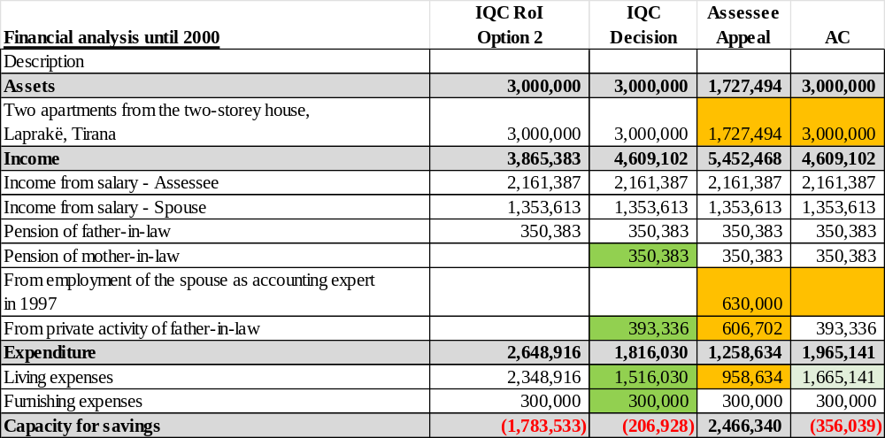
Referring to the analysis above of the period up to the year 2000, according to the file documents, analyzing the claims of the assessee and the analysis presented in a table in the appeal, we find the Commission's analysis to be correct, which resulted in a negative difference of -ALL 206.928. Therefore, the Commission's conclusions regarding the value of the building in Laprakë, Tirana are well-founded, and so is the value considered by the Commission as declared by the assessee constantly, of ALL 3,000,000; living expenses at 30% of the income as calculated by the Commission; income related to the father-in-law's activity that were considered in the analysis as the average of the minimum and maximum salary according to the DCMs of the respective years until 1997, as well as the non-consideration of the income from the husband in 1997 as an accounting expert - the possible consideration of the income according to the three reports that were submitted to the Commission for a potential total income of ALL 120,000, albeit the payment of taxes has not been proven - would reduce the negative difference concluded by the Commission respectively by this value [i.e., it would be –ALL 86.928].
It is noted that for the calculation of living expenses, the Commission concluded for a value of ALL 1,516,030, which from the calculations at the Chamber would be a value of ALL 1,665,141 [higher by ALL 149,111] since it is noted that according to the caselaw of the Chamber for the period 1991-1993 there was no capacity to accumulate savings in those years, due to the reality that has proven that the official currency, ALL, in this period incurred inflation at very high and extraordinary levels. while the Commission, as stated, seems to have considered 30% of the income for the entire period until 1999; and further for the years 1994 - 1999 at 30% as did the Commission for a total income of ALL 2,912,039, and while the expenses until May 2000 according to INSTAT for 6 people including the husband's parents and after the appointment in Tirana on 11.5.2000 for 4 people [total of ALL 531,000]. Considering these living expenses would worsen the situation of the assessee, so the negative difference would be - ALL 356,039, the possible consideration of the potential income of ALL 120,000 from the husband in 1997 according to the 3 reports, albeit the payment of taxes has not been proven, would result in a difference of – ALL 236.039.

B. Regarding the apartment 56 m², L. 13, Plazh, Durrës and shop 52.32 m² in Rr. “4 Dëshmorët”, Tirana, acquired in 2007;
In the Vetting Declaration the assessee stated: “Apartment, surface area 56 m², L.13 Plazh Durrës, purchased under contract rep. no. 1759, col 1406/2 dated 24.09.2007, mortgage document confirmation no.2842, dated 07.11.2007. Value ALL 2,000,000. Share 50%. Source: Income from salaries.”

“Shop, with an area of ​​52.32 m², 4 Dëshmorët Street. Reappraised in 2014, functions as a whole purchased according to the documentation: contract rep. no. 7895, col 992, dated 07.11.2007 and contract rep. no. 7896, col 993, dated 07.11.2007, cadastral zone certificate 8370, property no. 7/392-N3 and cadastral zone 8370, property no. 7/392-N2, with a total value according to the contracts of EUR 35,054. Value of EUR 35,054 converted to 4,276,588 ALL. Share 50%. Source: Income from salary. Sale of a 2+1 apartment in Gramsh in 2003.”

In the PAD 2007 stated: “Apartment 1+1 Contract no.1759 rep col 1406/2 date 24.9.2007. Durrës Beach. Value ALL 2,000,000.” Source not stated.

“Shop measuring 52 m² contract no.7896 rep col 993 contract rep no. 7895 col. no 992 dated 07.11.2007. ‘4 Dëshmorët’ Street Tirana. Value: EUR 15,852 and EUR 19,202.” Source not stated.

In the Declaration Before Assuming Office 18.11.2016 stated: “house, surface area 56 m², L13, Plazh, Durrës; year 2007. Value ALL 2,000,000. Source: Income from salaries.”

“Shop with 52 m² on 4 Dëshmorët Street, year 2007. Reappraised in 2014 (EUR 100,000). Value ALL 4,276,588. Source: Income from salaries, sale of 2+1 apartment in Gramsh in 2003.”

The Commission concluded in its decision (page 24, 33-34 of the decision):
- “48.6. At the conclusion of the administrative investigation, regarding the use of the accumulated cash amount for the purchase of three properties in 200744, it appears that the assessee: (i) provided clarifications on the cash balance in March 2009, well before the start of the vetting process, making her declaration before HIDAACI credible; (ii) no data was found that she and her husband had purchased other properties; (iii) despite not declaring the source of the creation of the three properties in 2007, she corrected this in the declaration in 2009 and in the Vetting Declaration, specifying as the source the income from salaries and the sale of the apartment in Gramsh, with which she had created cash savings over the years.”
- “53.3. From the above it results that the prices set in the sales contracts between the assessee and the construction company are calculated at a value very close to the minimum fiscal prices per square meter. Specifically, for the shop with an area of ​​28.66 m² x EUR 670 /m² the price was set at EUR 19,202 and for the shop with an area of ​​23.66 m² x EUR 670 /m2 the price was set at EUR 15,852. These prices bring the parties into a correct position before the tax authorities, but do not necessarily indicate the real sale price (not only for the assessee, but also for other buyers). In these circumstances, despite the fact that the Commission has calculated the value of the price according to the contracts as an expense, even though there has been no evidence of a conflict of interest and it has been proven that the assessee has purchased the units at a similar price to two other buyers, at the end of the process, the suspicion remains that the purchase price of these assets is not the real price.”
- “58.2. The Commission, after analyzing the claims of the assessee regarding the financial analysis for the purchase of the two shops and after taking into consideration some of the claims of the assessee, at the end of the process, revised the financial analysis and the negative balance decreased from ALL 3,828,530 to ALL 2,309,023. This improvement comes as a result of the review of the financial analysis for the period 1991 - end of 2003, a period during which the cash amount was created by means of which the three assets purchased in 2007 were paid.
- “58.3. As for the inaccuracies in the 2007 declaration, due to the lack of declarations of the source of creation of assets purchased during this year and the failure to declare the decrease in the cash balance, given that at the end of the process it resulted that the assessee and her husband have not justified with legal income the liquidity of ALL 4,000,000 at the end of the year 2003, which is claimed to be the source for the creation of assets purchased in 2007, these inaccuracies take on a specific weight, which put the assessee under conditions of insufficiency in declarations, according to the provisions of article 61/3 of law no.84/2014.

In the appeal, concerning this asset:
- - The assessee submits in the appeal that the cash balance accumulated by the end of the year 2006, which served as a source for the purchase of two assets in 2007, was in the amount of ALL 6,150,000. The assessee claims that she had sufficient lawful income to create the cash balance at the end of 2003, in the amount of ALL 5,700,000, as well as the addition during 2006, in the amount of ALL 450,000. The cash balance created by the end of the year 2006 is sufficient to be used as a source for the purchase of the two assets subject to verification. The failure to declare the source of the creation of assets and the reduction of the cash balance in the 2007 periodic annual declaration, contrary to what the Commission has concluded, are inaccuracies of a formal nature, not associated with financial insufficiency and as such do not constitute grounds for taking the disciplinary measure. .

- Regarding the purchase of the apartment in Durrës by sales contract dated 24.09.2007:
The situation following the review of documentation in the file:
- Apartment no. 58/64+1-23 with an area of ​​56 m2 in Durrës was declared in the PAD 2007 without declaring the source, and was further declared in the Declaration Before Assuming Office 18.11.2016 and the Vetting Declaration with the source of income from salaries.
- By contract of sale of apartment no. 1759/1406, dated 24.9.2007, the buyer Arben Çarçiu purchased from Artur Kala, apartment no. 23, with surface area 56 m², with property no. 58/64+1-23, in Plazh, Durrës, for the price of ALL 2,000,000. The contract states that the price was liquidated outside the notary office. With the answers to questionnaire no.2, the assessee also provided a payment slip for the price of apartment no.11 dated 24.09.2007 with a value of ALL 2 million with the description "for the purchase of apartment no. 23, with surface area 56 m², in ‘Shkëmbi i Kavajës’, Durrës, in favour of the entity Artur Kala, director of the company "Arena" sh.p.k.
- It is noted that, as the Commission has also noted, the assessee has declared the source of the creation of the apartment before the start of the vetting process before HIDAACI on 03.03.2009 [attached to questionnaire no.3] as well as before HIDAACI on 07.02.2017 [submitted by HIDAACI to the Commission] that the source was from the decrease in cash declared and carried over until 2007 - which the Commission has considered in the analysis it conducts further on the capacity to acquire the apartment with lawful resources. This analysis will be dealt with below together with the units also purchased in 2007 since both assets have the same source - the decrease of cash liquidity.

- Regarding the purchase of the shops in Tirana, by purchase contract dated 07.11.2007:
The situation following the review of documentation in the file:
- The units in ‘4 Dëshmorët’ Street, Tirana, no. 7/392-N3, with a surface area of ​​28.66 m² in the name of Brunilda Çarçiu and no. 7/392-N2 with a surface area of ​​23.66 m² in the name of Arben Çarçiu, were declared as a single unit of 52 m² (as explained during the process since they function as one) in the PAD 2007 without declaring the source, and were further declared in the Declaration Before Assuming Office 18.11.2016 and in the Vetting Declaration with the source of income from salaries. Proceeds of the sale of the 2+1 apartment in Gramsh in 2003.
- By contract of sale of unit no. 7895/992, dated 07.11.2007, the buyer Brunilda Çarçiu purchased from the company “I.N.C.O” shpk, unit no. 3, with an area of ​​28.66 m², with property no. 4/392-N3, in 4 Dëshmorët street, Tirana, at the price of EUR 19,202 (EUR 670 /m²). Likewise, by contract of sale of unit no. 7896/993, dated 07.11.2007, the buyer Arben Çarçiu purchased from the company “I.N.C.O” shpk, unit no. 2, with an area of ​​23.66 m², property no. 4/392-N2, in 4 Dëshmorët street, Tirana, at the price of EUR 15,852 (EUR 670 /m²). The contract states that the price was liquidated outside the notary office in instalments. In the replies to questionnaire no.2, the assessee has also provided a payment slip for the payments of the unit prices, four payment slip for the payment of certain amounts according to the respective dates by Brunilda Çarçiu in favour of the company “I.N.C.O” sh.p.k., with the description “for the purchase of a store” and, specifically, the payment slips: dated 2.11.2007, for the amount of EUR 5,000; dated 11.6.2007 for the amount of EUR 5,000; dated 16.7.2007, for the amount of EUR 4,500; dated 7.11.2017, for the amount of EUR 4,702. She also provided payment slips related to payments of certain amounts according to the respective dates by Arben Çarçiu, in favour of the company “I.N.C.O” sh.p.k., with the description “payment for the shop at R. C..” and specifically the payment slips: dated 4.5.2007, for the amount of EUR 4,000; dated 27.6.2007, for the amount of EUR 3,000; dated 18.9.2007, for the amount of EUR 4,000; dated 7.11.2007, for the amount of EUR 4,852.
- It is noted that, as the Commission has also established, the assessee has declared the source of creation for the unit/s before the start of the vetting process before HIDAACI on 03.03.2009 [attached to questionnaire no.3] as well as before HIDAACI on 07.02.2017 [submitted by HIDAACI to the Commission] that the source was from the decrease in cash liquidity declared and carried forward until 2007, with a source from salaries and from the sale of the apartment in Gramsh in 2003. which the Commission has considered in the analysis it conducts further on the capacity to acquire the unit/s with lawful resources. This analysis will be dealt with below together with the apartment purchased in 2007 since both assets have the same source - the decrease in cash liquidity.

- Financial analysis of the period until 2003 for generating liquidity in cash used as a source and the analysis of the period 01.01 - 07.11.2007 for the payments made for the unit/s in Tirana.

- As discussed above, the declared cash liquidity was used as a source for the purchase of the apartment on 24.09.2007 and the unit/s with payments made during 2007 until 07.11.2007.
- The assessee in the PAD 2003 declared cash liquidity "amount ALL 4,000,000 - savings from salary. Savings of income from employment over the years and private activity in Gramsh; and the amount ALL 1,700,000 – proceeds from the sale of a 2+1 apartment, privatized in Gramsh”;
In the 2006 PAD, he declared cash liquidity of ALL 450,000, which the Commission found to have been created with lawful sources and the assessee does not dispute it. Therefore, the cash balance declared until 2007 is ALL 6,150,000, as ascertained by both the Commission and the assessee.
In PAD 2007 the assessee did not declare a decrease in cash liquidity and did not declare the source for the assets created. But on 03.03.2009 before HIDAACI he stated that he has decreased cash liquidity. Also, in the Declaration Before Assuming Office dated 18.11.2016 he declared the sources of assets with income from salaries and from the sale of the apartment in Gramsh in 2003. He has also clarified before HIDAACI on 07.02.2017 that he used cash liquidity.
- The Commission, in the analysis of the investigation results, conducted an analysis of the capacity until 2003 for the declared cash liquidity of ALL 5,700,000 (4 million ALL and 1.7 million from the sale of the apartment in Gramsh) and concluded for a negative difference of -ALL 4,357,098. The Commission also conducted an analysis of the payments made in 2007, in the period 01.01-7.11.2007 [the moment of the last payment made for the unit] and concluded for a negative difference of -ALL 3,828,530 meaning that the assessee and the related person did not have lawful income for the purchase of the apartment and the unit/s.
- Following the assessee's objections in response to the investigation results, the Commission revised the financial analysis in the decision, where it is presented in a table, but from the narrative and from the analysis in the decision about what the Commission has accepted from the claims or considered in the analysis, it concluded only for the analysis 01.01-07.11.2007 [para.58.2] that from the difference of - ALL 3,828,530 it resulted in a smaller difference of -ALL 2,309,023, where it is stated that this improvement comes as a result of the review of the financial analysis for the period 1991 - end of 2003, a period during which the cash amount was created by means of which the three assets purchased in 2007 were paid.
- It is found that the assessee, in her response to the investigation results has the same claims that she had in the appeal addressed below. Referring to the appeal of the assessee in her analysis in the appeal in the form of a table, the analysis until 2003 has resulted in a positive difference of ALL 192,775 [para. 142, page 42], i.e., that she had capacity for cash amount of ALL 5,700,000; and that the analysis of the period when payments were made for the apartment and unit/s 01.01-07.11.2007 has resulted in a positive difference of ALL 171,471 [para. 177, page 46], i.e., that she had lawful resources for making payments. Regarding the claims, they are as follows:
  - The value/cost of the building in Laprakë, Tirana is ALL 1,727,494, not ALL 3,000,000, a claim that the Commission did not accept in the decision, claimed by the assessee and in the appeal – also addressed in the ground of appeal above, regarding the building in Laprakë, Tirana, where it was concluded that the Commission's conclusion is correct, i.e., the value of the building is 3 million ALL;
  - The income from the private activity of the father-in-law Rexhep Çarçiu, for the period 1993-1999, should be calculated at least at the value of ALL 606,720, a claim that the Commission has accepted in the decision and concluded for income referred to the average salary (of the minimum and maximum salary) at the value of ALL 393,336 according to the relevant DCMs of the years up to 1997, not including the years 1998-1999 - also addressed above in the ground of appeal for the building in Laprakë, Tirana, where it was concluded that the Commission's conclusion, namely including the value of ALL 393,336, is correct;
  - the amount of ALL 630,000, obtained in 1997 from the husband's activity as an authorized accounting expert in 1997 should be considered in the analysis as lawful income, a claim that the Commission did not accept in the decision and did not include in the analysis since the receipt of payments and the payment of taxes related to them were not proven – addressed also above in the ground of appeal for the building in Laprakë, Tirana, where it was concluded that the Commission's conclusion not including this income is correct. But although the inclusion of income based on the three reports that the assessee submitted to the Commission with a potential income value of ALL 120,000 could potentially be correct, although as for the other alleged income, the payment of taxes on them was not proven;
  - the inclusion of the mother-in-law's pension from 1991 - May 2000 of ALL 350,383, a claim that the Commission accepted in the decision and included in the financial analysis.
  - Furnishing expenses until 2003 of ALL 300,000 and ALL 500,000 until 2006 - a claim that the Commission accepted in the decision and considered in the analysis [para. 81, page 48 of the decision];
  - calculation of living expenses for the period up to 1999, in addition to the 30% reduction considered by the Commission, should be applied to this value and the 40% reduction due to the use of agricultural and livestock products produced in the household economy or ALL 2,142,066, a claim that the Commission has partially accepted in the decision the reduction of expenses as stated “[...] The extent of this reduction has been case by case. In the specific case, the Commission considered reducing living expenses from 66% of family income to 30% of them.” [para.43.4], “the reduction of living expenses for the period 1991 – 1999, a period when there are no official data from INSTAT, due to the use of products from agricultural land, a claim partially taken into consideration by the Commission, as argued in paragraph 43.4 of this decision [para.81]; and in the Methodology [para.82.2] “Living expenses for the years 1991 – 1999 are calculated at the rate of 30% of family income from salary; for the year 2000 for 6 people, for the year 2001 and onwards for 4 people based on the HIDAACI standard” - also addressed above in the ground of appeal for the building in Laprakë, Tirana, where it was concluded that the Commission's conclusion for calculating living expenses at 30% of income for the period up to 1999 where there is no data from INSTAT and onwards according to the composition of the family with data from INSTAT is correct. According to the calculations, the Commission has considered living expenses in the amount of ALL 2,699,462 in the analysis up to 2003. But according to the jurisprudence of the Chamber, it is concluded that living expenses up to 2003 should have been ALL 2.791.509 [i.e. higher by ALL + 92.047] as for the period 1991-1993 no savings could be accumulated in those years, due to the reality proving that the official currency, ALL in that period incurred inflation at very high and extraordinary levels while the Commission, as stated, seems to have considered 30% of income for the entire period up to 1999, and onwards, according to INSTAT.
We find the Commission's conclusion to be correct - that the assessee and the related person did not have sufficient lawful income to create the declared cash liquidity of ALL 5,700,000 until 2003, as they result in a negative difference of -ALL 2,480,493, i.e. they had capacity to accumulate savings of ALL 3.219.507.
Considering living expenses according to the calculations made at the Chamber, of + ALL 92,047 higher, would aggravate the situation of the assessee and would increase the negative difference or reduce the capacity for savings, therefore in order not to aggravate the situation of the assessee, the conclusion of the Commission is correct. The financial analysis until 2003 presented in the table below:
Table no.2 – Comparative analysis of the period until 2003 to generate the liquidity in cash declared in the amount of ALL 5.700.000, according to the Commission in the report on the results of investigation, according to the narrative in the decision, the assessee in the appeal and the analysis at the AC.
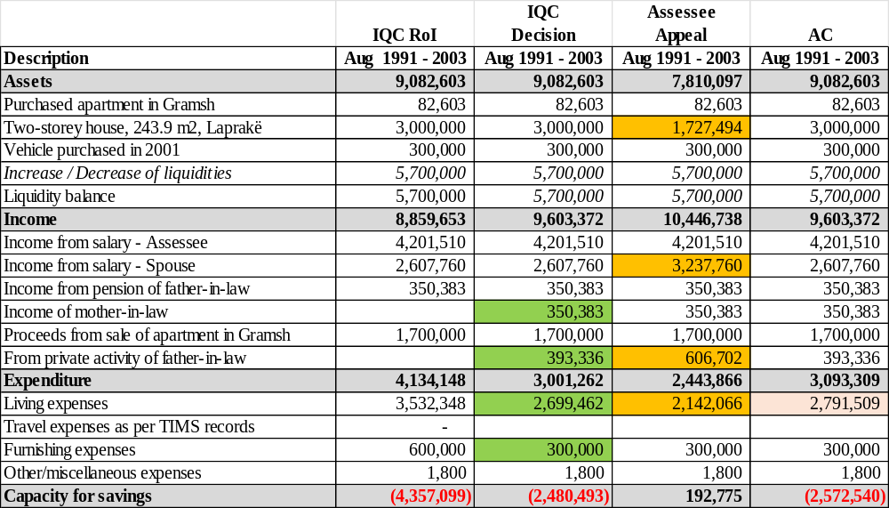

- Referring to her analysis in the appeal presented in a table, for the period when the payments for the apartment and the unit/s were made, from 01.01.2007 to 07.11.2007 [moment of payment of the last instalment according to the payment slips for the unit/s] the assessee noted a positive difference of ALL 171.471 [para.177, page 46] i.e., that she had lawful resources to make the payments. The Commission concluded in the decision that this analysis results in a negative balance of -ALL 2.309.023. The Commission’s result is correct, that the assessee lacked sufficient lawful income to accumulate cash savings until 2003, which were declared and explained as used for the purchase of the apartment and the unit/s and this incapacity has affected the negative result of the analysis for the purchase of the apartment and unit/s.

Table no. 3 – Comparative analysis of the period 01.01-07.11.2007 for the purchase of the apartment and unit/s in 2007, according to the Commission in the report on the results of investigation, according to the narrative in the decision, the assessee in the appeal and the analysis at the AC.
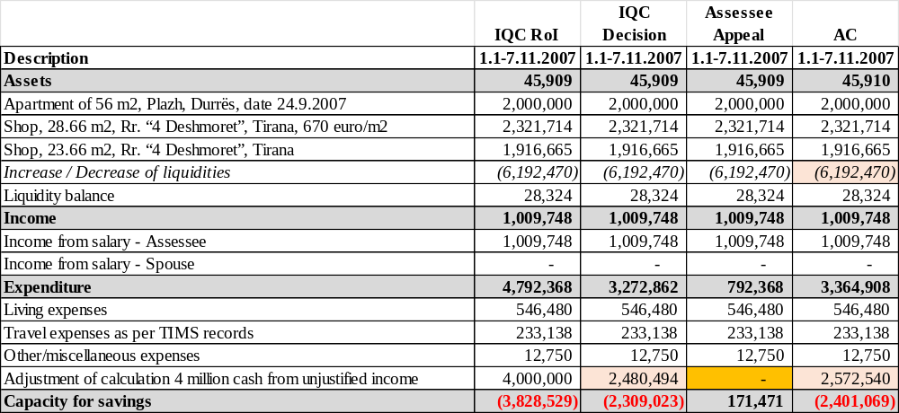
Note:: In this analysis, it was considered that the amount of 6,150,000 ALL, saved from salaries over the years, declared as cash balance starting from the Declaration Before Assuming Office in 2003 until the end of 2006, was used to purchase three properties. However, since the assessee did not have sufficient lawful income to create cash savings until 2003, as stated above – which resulted in a negative difference of –ALL 2,480,494, this incapacity has affected the negative result of the analysis for the period 01.01-07.11.2007, which resulted in a difference of –ALL 2.309.023.
At the AC, this difference is –ALL 2.401.069, i.e., higher by of ALL 92,046 which comes from the negative difference in the analysis until 2003 for the creation of liquidity in cash until 2003 from the recalculation of living expenses higher than the Commission. In order not to aggravate the situation, the Commission's conclusion is correct.

C. Regarding the proceeds from lease of 52.32 m² unit, in Rr. “4 Dëshmorët”, Tirana;
In the Vetting Declaration, the assessee stated: “From lease of the shop, rented out under contracts rep. no. 904, dated 23.02.2010, one year term, rental of ALL 20,000 /month and rep. no. 29, col 18 dated 06.01.2012, one-year term, rental of ALL 20,000 /month. Value ALL 480.000.
From lease of the shop according to contract rep. no. 1344, col. no. 654 dated 13.06.2016, amount of ALL 16.500 /month. Value, ALL 115.500.”

The Commission concluded in its decision (page 31-25 of the decision):
- “55.4. Based on the above, only the portion of rental incomes for which tax obligations have been paid, namely the net rent for the months of November-December 2016, in the amount of ALL 28,050, has been included as lawful income in the financial analysis of the assessee for the period 18.11.2016 (the date of the assessee's appointment as an advisor at the High Court) until 31.12.2016. This amount represents the net rental for 2 months and is exactly 16,500 x2 = ALL 33,000 and after deducting the 15% tax, the amount is ALL 28,050.].
- “55.7. From the analysis of the submitted documentation, it is found that the assessee has paid the rent tax in the amount of ALL 144,000 relating to the periods 2009, 2010, 2012 and 2013, while she has not submitted a rental contract for the year 2007, despite the fact that in the PAD/2007 she claimed rental income in the amount of ALL 88,000 and for the year 2013, on which she paid the tax at source.”
- “55.8. At the end of the process, the Commission concluded that the rental income for the years 2008, 2010, 2012 and 2016, the tax on which was paid by the assessee after the results of the investigation were submitted, to be considered legitimate, referring to the following facts and circumstances. […].

In the appeal, concerning such income:
- - The assessee disputes the conclusion of the Commission, which did not take into account the income generated from the rental of the 52.32 m2 unit, located on “4 Dëshmorët” street, Tirana. The Commission has recognized the rental income for the years 2009, 2010, 2012, 2016, but despite the evidence presented by the assessee, it has not included it in the financial analysis, and the IQC has not unjustly recognized the rental income for the year 2013.

The situation after reviewing the documentation in the file:
- 1. Regarding the rental income, it is found that the assessee has declared in the Vetting Declaration for the year 2010 for 12 months, rental of ALL 20,000, i.e., ALL 240,000, for the year 2012 for 12 months rental of ALL 20,000, i.e., ALL 240,000 and in total she has declared an amount of ALL 480,000. He has also declared for the year 2016 from 13.06.2016 for 7 months rental of ALL 16,500, amount of ALL 115.500.
- The assessee has also declared rental income over the years:
- - in the PAD 2007, rental income according to the contract dated 10.4.2007, in the amount of ALL 80,000, which was not submitted by the assessee;
- - in the PAD 2008, he did not declare rental income;
- - in the PAD 2009, he declared rental income according to the contract dated 30.1.2009, in the amount of ALL 220,000, with Gazmir Çera, which was submitted by the assessee with his objections;
- - in the PAD 2010 he declared rental income according to the contract dated 30.1.2009 and the contract dated 01.02.2010, with Gazmir Çera in the amount of ALL 240,000, which was submitted by the assessee during the process in the Commission (but the contract is dated 23.02. 2010);
- - in the Declaration after leaving office 03.03.2011 he declared rental income in the amount of ALL 40,000 according to the contract dated 01.02.2010 for 2 months;
- - in the Declaration Before Assuming Office 18.11.2016 the assessee declared "income from the monthly rental of the shop according to the contract dated 13.6.2016, with Ëngjëllushe Dura;; amount of ALL 16,500 /month, which was submitted by the assessee during the process at the Commission
- - in the PAD 2016 the assessee declared “Rental income of ALL 16,500 per month from June 2016” amount of ALL 115,500;
- - In questionnaire no.2, the assessee clarified regarding the rental income that contracts have been concluded, and has also attached Contract no.29 rep, no.18 col, dated 06.11.2012 where it is stated that it starts on 05.01.2012 with a term of 1 year until 05.01.2013, but has explained that it lasted 2 years or less, while she was not a declaring subject. The premises was rented out for pharmacy activity.
- The Commission, in its analysis in the report of the results of investigation, considered rental income in the financial analysis of the period outside office term, from 03.03.2011 to 18.11.2016 of ALL 28,050, i.e. for 2 months, and in the analysis for the term in office from 18.11.2016 to 31.12.2016, of ALL 28,050 for 2 months (net income after tax).
- Following the objections of the assessee who claimed the inclusion of rental income for all the years she declared, attached to the objections the lease contracts for the years 2009, 2010, 2012 and 2016. She also attached letter no. 1710 prot., dated 20.5.2022, of the Taxpayers Service Directorate for the payment made for the rental tax in the amount of ALL 144,000, which states that according to the description of the slip of the American Investment Bank, it belongs to the periods 2009, 2010, 2012 and 2013. Therefore, it is noted that the bank's slip is not attached. The payment made of ALL 144,000 is considered the payment of 15% tax on rental income in 2009, 2010, 2012 and 2013 a total of ALL 980,000.
- The Commission in the final analysis in the decision, according to the analysis of the decision, that is, the narrative, is found to have considered rental income in the years 2009, 2010, 2012 and 2016. In the decision [paragraphs 55.7 and 55.8] it is stated that “55.8. At the end of the process, the Commission decided to consider the rental income for the years 2008, 2010, 2012 and 2016 as legitimate, the tax on which was paid by the assessee after receiving the results of the investigation, referring to the following facts and circumstances: […]” it is found that the Commission considers rental income in 2008, but it seems to be a lapsus since it should be in 2009, since in 2008 the assessee did not declare rental income and the certificate brought by the assessee with the objections from the Tirana RTD no.1710 prot. dated 20.05.2022 confirms the payment of taxes on rental income for the years 2009, 2010, 2012 and 2013.
Also, further on in the decision in para.81, page 48, it is stated that "rental income for the years 2009 and 2010, be included, a claim that was taken into consideration by the Commission, as argued in paragraph 55.9 of this decision;"
Likewise in para.82.1 page 48 "the income received from rental for the years 2009, 2010, 2012 and 2016 (from 13.6.2016);"
and in para.74, page 43 for the analysis conducted outside the term in office, 03.03.2011-18.11.2016 “rental income be included in total of ALL 484,125. From the analysis of the documents, facts and circumstances related to the rents, addressed in paragraph 55 of this decision, the Commission considered including the amounts received from the rent in the analysis of the year 2012 and five months for the year 2016”.
- So, the Commission in its decision [para.55.7] did not take into account the rental income for the year 2007 regardless of the fact that it was declared in the amount of ALL 88.000 and for 2013 die to failure to submit a lease contract.
- The assessee in the appeal claims that the Commission has recognized the rental income for the years 2009, 2010, 2012, 2016, but despite the evidence presented by the assessee, has not included it in the financial analysis, we find this claim to be unfounded since referring to the analysis in the narrative of the decision, the Commission changed the position from the analysis made in the report on the results of investigation to the analysis in the decision, and the results of the analysis, referring to the analysis of the Renault vehicle purchased on 06.11.2010 where the negative difference was reduced [para.60.5]; the analysis of the Mercedes Benz vehicle purchased on 29.05.2010 where the negative difference became positive [para.64.4, page 37]; total financial analysis [para.81, page 48] where the overall negative difference decreased from 9,222,340 ALL to 4,824,260 ALL [this as a result, among other things, of: the decrease in the negative difference of 2009 from – ALL 329,152 to – ALL 109,152 (considering rental income of ALL 220,000) and the decrease in the negative difference of 2010 from – ALL 1,211,116 to – ALL 1,001,116 (considering rental income of ALL 210,000)].
- Regarding the rental income for 2013, the assessee, as the Commission concludes, did not submit a rental contract for 2013, the most recent contract is the one submitted with questionnaire no. 2, where the assessee has explained regarding the rental income that contracts have been concluded, and has also attached Contract rep no. 29, col no. 18, dated 06.11.2012, where it states that it starts on 05.01.2012 with a term of 1 year until 05.01.2013 with a rental of 20,000 ALL/month, but has explained that it lasted 2 years or less, when she was not a declaring subject. The unit was rented out for pharmacy activity. So, in the appeal, the assessee claims that the entity Marsela Velo continued the activity in that store and for the year 2013 onwards she left the activity, and that the assessee has also paid the tax for this income, we find the claim of the assessee to be unfounded because i) in the contract of 2012 no.29/18 dated 6.1.2012 in article 11 it is stated that "changes and additions to this contract will be valid only if they are in writing and signed by both parties" and the assessee has not submitted another contract/act for the year 2013; ii) the payment of tax in itself for the year 2013 does not make legitimate a claimed income that is not declared in the Vetting Declaration but that is not proven to have been obtained through a lease contract, and in these conditions the Commission's conclusion for not including the 2013 rentals, seems to be well-founded. Refer also to the AC Decision on assessee Simon Pashuku no.12/2022.

So, in the financial analysis, the rental income is as follows:
- In 2009, the IQC took into account according to lease contract dated 30.01.2009, for 11 months at ALL 20.000, total of ALL 220.000, likewise the assessee and the AC.
- In 2010 IQC seems to have considered according to the lease contract dated 23.02.2010 for 10.5 months at ALL 20.000, total of ALL 210.000 and the assessee has considered ALL 240.000. It seems to be correct what the assessee considered, since in January the contract dated 30.01.2009 for 1 year, i.e., ALL 20,000, was valid and with the contract dated 23.02.2010, which started with validity from 15.02.2010 for 1 year, i.e., 10 months at ALL 20,000, totalling ALL 220,000.
- For the analysis up to 03.03.2011, the IQC and the assessee seem not to have considered rentals, but the assessee declared in the declaration after leaving office on 03.03.2011 rent for 2 months of ALL 40,000. Including rentals of 40,000 ALL for 2 months seems to correct.
- For the analysis from 18.11.2016 - 31.12.2016, the IQC has considered the net value of ALL 28,050 for 2 months of 2016 according to the analysis in the report on results of investigation. Meanwhile the assessee does not have an analysis presented in a table for this period in the appeal. According to the declarations of the assessee in the Declaration Before Assuming Office 18.11.2016 and according to the contract dated 13.06.2016 for 1 year with the right to renewal for ALL 16,500 /month, the calculation according to the Commission for ALL 28,050 net rental income, is correct.
- For the analysis outside term in office, 03.03.2011 - 18.11.2016, the IQC has considered as analyzed in the decision (para.74, p. 43) that it has included income for the year 2012 and 5 months of 2016 or ALL 310,125, the assessee claims for the value of ALL 484,125 net or for the total year 2012 of ALL 240,000, for the year 2013 of ALL 240,000 and for 2016 for 5.5 months of ALL 90,750, total of ALL 570,750. It seems that the consideration as the Commission has done is correct, since the income from the rental for the year 2013 as stated above, is not considered.

D. Regarding the cash balance at the end of 2010 and on 03.03.3011;
The Commission concluded in its decision (page 46-47 of the decision):
- “79.2. As for the assessee's financial capacity to accumulate cash savings over the years, they are reflected in the financial analysis for the vetting period, according to which the assessee did not have lawful income for the years 1991 until the end of years 2003, 2008, 2009 and 2010. In her submissions, the assessee has contested the Commission's financial analysis and has presented an analysis according to which the above periods result in positive balances.”
- “[...] ii) 1.8.1991 – 3.3.2011 and 18.11.2016 - 31.12.2016, when the assessee is in office, which at the end of the process resulted in a negative balance of ALL 3.668.345.”

In the appeal, concerning this property:
- The assessee states in the appeal that the cash balance at the end of the year 2010 remains in the amount of ALL 1.500.000, and the correction for this balance was made in the PAD of 2016.

The situation after reviewing the documentation in the file:
- Regarding the liquidity in cash, the assessee declared cash over the years as follows;
- In the PAD /2003 the assessee declared in the section “Liquidities”: “(i) amount of 4.000.000 – savings from salary. Savings of income from employment over the years and private activity in Gramsh; and (ii) amount of ALL 1.700.000 income from sale of two-bedroom apartment [privatized] in Gramsh”. So, at the end of the year 2003, the cash balance is ALL 5.700.000, considered the same as in the analysis of the Commission and the analysis of the assessee in the appeal presented in a table [page 56].
- In questionnaire no. 3 the assessee informed that in the PAD/2003 resubmitted it to HIDAACI at the request of the latter on 28.3.2007, as the declaration in question had been lost and in response to the question of the inspector about savings of the years 2004 and 2005, the assessee stated that in these years the cash balance was the same as in 2003.
- In the PAD 2004 and PAD 2005 the assessee has not declared any additions or decreases in the cash balance, while from the information provided by the Bank of Albania it is evident that on 7.7.2004 the assessee invested the amount of ALL 3,500,000 in treasury bills maturing on 20.1.2005. Asked about this transaction, in response to questionnaire no. 3, the assessee stated that: "Given the fact that at that time I had all my savings in cash, I declared as cash balance the proceeds from the apartment in the amount of ALL 1,700,000, sold in 2003 and the amount of ALL 4,000,000, including in this amount the undeclared cash balances of 2004 and 2005. To prove this fact, I am also submitting the document from the Bank of Albania, from the Monetary Operations Department, dated 6.1.2022, which reflects the participation in the auction on 7.7.2004, with a nominal value of 3,500,000 for a 6-month period, as well as the interest in the amount of ALL 135,000". Thus, the cash balance, created over the years, was used to invest in treasury bills in July 2004, which matured in January 2005 and was again kept in cash at home from January 2005, to be used for the purchase of three properties in 2007. Thus, the cash balance at the end of the year 2004 was ALL 2,200,000 and at the end of the year 2005 was the same, ALL 5,700,000 [after maturity of the treasury bills] considered the same as in the Commission's analysis and in the assessee's analysis presented in a table in the appeal [page 56].
- In the PAD 2006 the assessee declared “Savings of income for the year 2006 amount in cash of ALL 450,000”. So, at the end of the year 2006, the cash balance was ALL 6,150,000 considered the same as in the Commission's analysis and in the assessee's analysis in the appeal [page 56].
- - In the PAD 2007 the assessee declared: "Savings from income for the year 2007 cash amount, ALL 3,000,000 ", in the declaration the assessee declared the value of 3 million ALL but before HIDAACI on 03.03.2009 she specified that the amount was ALL 300,000.
- - In 2007, the assessee did not declare a decrease of the amount of ALL 6,150,000, but on 3.3.2009, before HIDAACI, the assessee explained that: (i) the assets created in 2007 have their source of creation from the decrease in the cash balance in the amount of ALL 6,150,000, (cash balance declared in the years 2003 – 2006); and (ii) the balance created by means of salary savings for the year 2007, i.e., the cash balance is ALL 300,000, I have erroneously declared ALL 3,000,000”. Thus, at the end of the year 2007 the cash balance was ALL 300,000, considering that the amount of ALL 6,150,000 was used for the purchase of three assets in the year 2007, considered the same as in the Commission's analysis and in the assessee's analysis in the appeal. [page 56].
- In the PAD 2008 the assessee has declared: “Cash income from salary savings for the year 2008, 500,000 ALL”. At the end of the year 2008, the cash balance was ALL 800,000, considered the same as in the Commission's analysis and in the assessee's analysis in the appeal [page 56].
- In the PAD 2009, the assessee has stated: “Cash savings from salary and rent income for the year 2009, ALL 700,000”. At the end of the year 2009 the cash balance is in the amount of ALL 1,500,000, considered the same as in the Commission's analysis and in the assessee's analysis in the appeal [page 56].
- In the PAD 2010 (submitted 29.03.2011) the assessee stated: “Cash savings from salary and rent income for the year 2010, 700,000 ALL”. At the end of the year 2010 the cash balance by the Commission is considered as a continuation in the amount of ALL 2,200,000, while the assessee clarified before HIDAACI on 07.02.2017 that the cash balance on 31.12.2015 was ALL 1,500,000 [while the assessee at that time was not a declaring subject], he again explained in the response to questionnaire no.3 to the Commission that at the end of the year 2010 the balance was ALL 1,500,000, he explained the same in the objections to the investigation results and raises it as a ground of appeal [to be elaborated below].
- In the Declaration after leaving office 03.03.2011 (submitted 29.03.2011) the assessee did not declare anything about the cash balance, therefore at the end of the year 2011 the cash balance was considered the same at the value of ALL 2,200,000 by the Commission and by the assessee that it had the same balance of ALL 1,500,000.
- In the Declaration Before Assuming Office 18.11.2016 (submitted 16.12.2016) the assessee has declared: “Cash balance (from savings over the years, shop rentals) 900,000 ALL”, considered the same as in the Commission's analysis and in the assessee's analysis in the appeal [page 56].
- In the PAD 2016 (submitted 27.03.2017) the assessee stated: “Cash balance reduced from ALL 1,500,000 remains at the amount of 900,000 ALL”. At the end of the year 2016 the cash balance is at the value of ALL 900,000, considered the same as in the Commission's analysis and in the Vetting Declaration, the assessee declared: “Cash balance of ALL 900.000. Source: savings”.
- The Commission in the report on results of investigation considered that the assessee did not have lawful income to create the Cash savings for the years 1991 until the end of 2003, 2008, 2009 and 2010. Referring to the financial analysis in the report on results of investigation, the Commission found that:
- For the period 1991- 2003 the assessee was in a negative difference of -ALL 4.357.098 [analyzed also for the assets purchased in 2007 apartment in Durrës and unit/s in Tirana];
- For 2008, resulted in a negative difference of -ALL 57.009;
- For 2009 resulted in a negative difference of -ALL 329.152;
- For 2010 resulted in a negative difference of -ALL 1.211.116.
- The assessee in her objections has contested the financial analysis of the Commission and has presented an analysis according to which, the above periods result in positive balances. The assessee claimed the same in her appeal in her analysis regarding the assets (presented in a table) [page 56] – which will be elaborated below in the ground of appeal regarding the financial analysis of the total years. It is noted that the Commission in the decision after reviewing the financial analysis of the years has accepted some of the claims of the assessee, since from the analysis of the Commission's decision where it concludes that "the negative balance changes from ALL 9.222.340 to ALL 4.824.260" So the negative balance decreased compared to the negative balance in the report of the investigation results; we find that the Commission in the decision has not presented an analysis of the final years again, but by analyzing the decision and accepting the claims from the assessee, it results that the Commission has concluded for:
- For the period 1991- 2003, from a negative difference of -ALL 4.357.098 to a smaller negative difference of -ALL 2.480.493 [analyzed also for the assets purchased in 2007, apartment in Durrës and unit/s in Tirana];
- for the year 2008 from a negative difference of -ALL 57,009 to the same negative difference of -ALL 57,009;
- for the year 2009, from a negative difference of -ALL 329,152 to a smaller negative difference of -ALL 109,152;
- for the year 2010 from a negative difference of -ALL 1,211,116 to a smaller negative difference of -ALL 1,001,116.
The analyses of the years 2008, 2009 and 2010 shall be presented under the ground of appeal below in the section of the financial analysis of the years in total.
- It is established that the assessee challenges the cash liquidity balance in 2010, claiming that it should have been calculated at 1,500,000 ALL and not ALL 2,200,000 as the Commission did, since the clarification regarding this cash liquidity was made in the 2016 PAD. In consideration of the assessee’s claim, it is noted that with regard to the cash liquidity balance of 2010 in the amount of ALL 1,500,000 the assessee has provided explanations in the documents listed chronologically as follows:
- In the HIDAACI minutes of 07.02.2017, forwarded to the Commission through letter no. 2673/2 prot., dated 28.04.2020, the assessee and her husband (both declaring subjects) have made disclosures regarding the source of creation of the cash liquidity declared in the 2003 PAD, the corrected cash liquidity balance in 2007 (ALL 300,000 balance) included by the Commission in the financial analysis, and that the cash liquidity balance on 31.12.2015 was ALL 1,500,000 [a time when the assessee was not a declarant to HIDAACI due to the post she had], which she used in 2016.
- In the 2016 PAD, submitted on 27.03.2017, she declared that: “Cash balance reduced from 1,500,000 ALL to 900,000 ALL”
- In questionnaire no. 3, the assessee explained the progress of cash liquidity and that balance at the end of 2010 was ALL 1.500.000, I cite “[...] income from lease as per the submitted statement, the cash balances of 2008, 2009 and 2010 are added to the cash of 2007, and the total cash balance on 3 March 2011 is 2,200,000 ALL. We need to clarify that we purchased in 2010 two cars and made a trip to Turkey, which were afforded with the previously accumulated cash balance of 700,000 ALL. So, the cash balance at the end of 2010 was 1,500,000 ALL. It is established that in the Declaration of Private Interests Before Assuming Office on 18.11.2016, submitted on 16.12.2016, is disclosed: “Vehicle Renault, purchased on 06.11.2010 at the price 270,000 ALL. Source: savings from salaries”.
- It is established that: (i) the assessee has clarified in the 2016 PAD, - submitted on 27.03.2017, i.e., prior to the start of the re-evaluation process - that the cash balance at the time she left office on 03.03.2011 was 1,500,000 ALL (ii) the submission of the resignation declaration on 03.03.2011 and of 2010 PAD on the same date, 29.03.2011, and their proximity in time, insofar as not confirmed that the assessee created other assets from 31.12.2010 to 03.03.2011, makes it more credible that the cash liquidity balance was the same; (iii) according to explanations provided in Questionnaire no. 3, the assessee declared that with the cash liquidity of 2010 she purchased two vehicles and had a trip to Turkey, therefore the balance at the end of 2010 was 1,500,000 ALL; this fact is supported by the Declaration Before Assuming Office on 18.11.2016, in which the assessee declared the Renault vehicle with source “savings from salaries”; and (iv) in the HIDAACI minutes of 07.02.2017, she explained that the balance as of 31.12.2015 was 1,500,000 ALL [a time when the assessee was not a declaring subject] and that she had the same cash balance as when she left office on 03.03.2011 at the end of 2010, since according to documents and the Commission’s analysis, no assets were created during the period when the assessee was not in office. Therefore, seems to be valid the assessee’s claim that the cash liquidity balance on 31.12.2010 was 1,500,000 ALL. This change, compared to the Commission’s analysis, will result in a change in the analysis for the year 2010, which will be addressed in the subsequent appeal ground in the overall financial analysis.

E. On the vehicle Mecedes Benz, purchased on 29.05.2010;

In the Vetting Declaration, assessee’s spouse has disclosed: “Mercedes Benz vehicle, Sale Contract no. 2472/ 2204, dated 29.05.2010, plated TR8567T. Value 630,000 ALL. Share 100%. Source of creation: Income from salary and proceeds from sale of previous Mercedes Benz 190 vehicle amounting to 400,000 ALL.

In the 2010 PAD id disclosed: “Purchase of a vehicle according to sales contract no. 2472 rep., and 2204 col., dated 29.05.2010. Value: 630,000 ALL”. The source is not declared.

The Commission concluded in the decision (page 38 of decision):
“The financial analysis showed that the assessee had the capacity to purchase the vehicle on May 29, 2010, despite a negative balance of -53,357 ALL, which was assessed as insignificant. With the review of the financial analysis at the end of the process, including in this analysis the income from the rent for the analyzed period, this balance turned from negative to positive”.

Regarding this asset, in the appeal is stated:
- Regarding the purchase of this vehicle, the Commission identified a negative balance of 53,357 ALL, which was assessed as insignificant. The assessee claims in the appeal that even this negative balance, in fact, results as positive according to the financial analysis”.

Situation after reviewing documents in the file:
- The assessee’s spouse declared the Mercedes Benz vehicle, plated TR 8567 T, as his own in the vetting declaration, stating as source the salary income and proceeds from the sale of the previous Benz 190 for 400,000 ALL. The assessee has disclosed the purchase of this vehicle in the PAD/2010, but without declaring the source of its creation.
- Has attached to the vetting declaration, the sales contract no. 2472/2204 dated 29.05.2010, by which citizen Arben Çarçiu purchased from citizen Ylli Cullhaj a vehicle Daimler Chrysler (C 200 CDI) for ALL 630,000, a payment to be received by the seller upon registration of the vehicle.
- GDRTS confirmed that the vehicle plated TR8567T is registered in ownership of Arben Çarçiu, which, based on the chassis number, pertains to the vehicle subject to verification.
- According to the Sale Invoice of 11.12.2009, the citizen Ylli Cullhaj had purchased this vehicle in Germany for 2,800 EUR, and based on the Customs Declaration of 13.12.2009, the vehicle was cleared for 268,694 ALL.
- In relation to proceeds from sale of previous Mercedes Benz 190, amounting to 400,000 ALL, it is found that:
-By Sale Contract no. 3429 rep, no. 909 col, dated 30.06.2010, Arben Çarçiu has sold to the citizen Ilmi Kaçani a Mercedes Benz vehicle plated TR7298I, for 400,000 ALL, paid outside the notary office. This sale was declared by assessee in the PAD of 2010. As noted, this vehicle was sold 1 month after purchase of the vehicle Mercedez Benz, date 29.05.2010. When asked during the vetting process about this fact, assessee explained in questionnaire no.2 that they had received the money from the buyer upon delivery of the vehicle, and that the contract was formalized later, and this occurred because of other commitments of the buyer and lack of time, based on mutual trust. This explanation of the assessee was considered convincing, and for this reason the proceeds from the sale of the Benz vehicle, with license plate TR7298I, were included as a source for the purchase of the vehicle under review on 29.05.2010.
- In relation to the method of acquisition of the Mercedes Benz 190, plated TR7298I, is declared in PAD 2005 worth 250,000 ALL, without declaring sources of creation. In reply to questionnaire no. 2, assessee presented the Sale Contract no. 5094/523, dated 02.06.2005, in the value of 250,000 ALL. The Commission concluded that the assessee had lawful income to purchase this vehicle.
- When asked about the reasons for sale of this vehicle 5 years later at a higher price (400,000 ALL) than the purchase price 250,000 ALL, the assessee explained in reply to questionnaire no.2 that there was no specific reason apart from the fact that the buyer wanted to purchase this type of Mercedes Benz, which was well maintained and in good technical condition, which would serve to his activity. Given that the Commission deemed this claim stands in a declarative level and the assessee could not justify the sale of this vehicle at 40,000 ALL, (i.e. almost twice as much five years after the time of purchase) in 2010, in the financial analysis regarding the capacity to purchase the vehicle Benz on 29.05.2010 and in 2010 considered as lawful income from its sale the value 250,000 ALL and not the value of ALL 400,000 as per the sales contract.
- The financial analysis 01.01.-29.05.2010 conducted by the Commission and sent with the results of the investigation showed that the assessee had the capacity to purchase the vehicle on May 29, 2010, despite a negative balance of -53,357 ALL, which was assessed as insignificant. In the decision [para.64.4, page 38] the Commission concluded: With the review of the financial analysis at the end of the process, including in this analysis the income from the rent for the analyzed period, this balance turned from negative to positive. Thus, the Commission did not attach consequences to the purchase of the Mercedes Benz vehicle on 29.05.2010 and, concluded after revising the analysis that the balance is positive; in these conditions, the assessee’s ground of the appeal is not valid”.

F. On the vehicle Renault, purchased on 06.11.2010;
The assessee disclosed in the Vetting Declaration: “Renault vehicle, Contract rep. no. 10641, col. no. 7293, dated 06.11.2010, price 270,000 ALL. Value ALL 270,000. Share 100%. Source of creation: Savings from salaries.

In the 2010 PAD, the assessee declared: “Purchase of vehicle under contract no. 10641 rep., and 7293 col., dated 06.11.2010. Value: 270,000 ALL. Share 100%. The source is not declared”.

In the Declaration of Private Interests Before Assuming Office on 18.11.2016, the assessee declared: “Renault vehicle, purchased on 06.11.2010 for ALL 270,000. Source: Savings from salaries”.

The Commission concluded in decision (page 36 of decision):
- “60.5. The negative result after the Commission analyzed the assessee’s claims, after reviewing the analysis at the end of the process and including the rental income for the period under analysis decreased from – 454,170 ALL to – 334,170 ALL”.

Regarding this asset, in the appeal is stated:
- The assessee refutes the Commission’s conclusion regarding the husband’s financial shortage of ALL 334,170 to purchase the vehicle, claiming that the financial analysis regarding the capacity to purchase it on 06.11.2010 shows a positive balance.

Situation after reviewing documents in the file:
- The Renault vehicle purchased by the assessee on 06.11.2010, was declared in the Vetting declaration, in the 2010 PAD and in the Declaration Before Assuming Office on 18.11.2016, with source being savings from salaries. However, the source was not declared in the 2010 PAD.
- The assessee has attached the sales/purchase contract no. 10641/7293, dated 6.11.2010, with seller Aldo Brahimi, for the price 270,000 ALL. The parties state in the contract that the price was settled and they have no claims about the technical condition of the vehicle. The assessee has attached also documentation for the purchase, the Customs declaration dated 13.06.2010 shows that Mr. Aldo Brahimi purchased this vehicle in Germany for the price 1,950 EUR and paid Customs clearance fees of 137,893 ALL, i.e. total ALL 408, 573 as confirmed by the Commission. During investigation the Commission shifted the burden of proof to the assessee on the following: the purchase price is twice the price at which the assessee bought the vehicle five months later. The assessee explained that she did not have acquaintance with the seller and that shortly afterward she encountered problems, which may also have been the reason that, as per attestation submitted to the Commission, there was no conflict of interest and she did not compile opinions/reports for the High Court. In conclusion, the Commission in decision [paragraph 60.2] did not consider the purchase price as a reason to penalize the assessee, although it regarded the purchase price as questionable. Additionally, in the financial analysis on the capacity to purchase, the Commission considered as purchase price the one set out in the sale/purchase contract, accounting for 270,000 ALL.
- The Commission prepared a financial analysis 29.05.2010-06.11.2010 to determine whether the assessee had the means to purchase the vehicle. The start date of the analysis is 29.05.2010 to avoid the overlap of results, because another vehicle Benz was purchased on the same date by her husband (analysed above). In the results of investigation, the period under analysis 29.05–06.11.2010, resulted in a negative balance of –454,170 ALL. In conclusion, the Commission states in its decision [paragraph 60.5] that the negative balance is reduced to –334,170 ALL after rental income was taken into account in the analysis.
- The assessee concludes in the appeal that as per this analysis the balance is positive; the table of analysis for the period 29.05–06.11.2010 shows a positive balance of +381,759 ALL, after considering: a) income at ALL 935,929 higher than the Commission, from: i) rental income at ALL 220,000; ii) income from the sale of the Benz TR 7298I in the amount of ALL 400,000; iii) donation from the Robo family in the amount of 2,000 USD. The assessee claims in the appeal that the overall financial analysis for 2010 results in a positive balance of +94,813 ALL. The assessee claim in the appeal, inter alia, that alike the Commission, the assessee had cash liquidity declared at ALL 1,500,000. This amount is potentially used during the year for expenses or purchase of assets, and is completed with annual income. Cash liquidity cannot be calculated at a specific time during the year because it is only declared at the end of the year.
- Regarding the financial analysis for the period 29.05–06.11.2010, with regard to the assessee’s claims (table in paragraph 2121, page 53) it is noted that:
- On the claimed ALL 220,000 rental income, it is observed that the Commission concluded to include the rental income, thus reducing the negative balance by ALL 120,000 (from –454,170 ALL to –334,170 ALL). i.e., the included rental income corresponds to a proportional annual amount for 6 months, from June to November 2010. In contrast, the assessee considered rent for 11 months (20,000 ALL/month for 11 months, totalling 220,000 ALL). It is considered to be fair the Commission’s inclusion of rent for 6 months, from June to November 2010 i.e., in the amount of 120,000 ALL.
- On the claimed ALL 400,000 income from the sale of the Benz TR 7298I; the assessee has also included income from the sale of the Mercedes Benz plated TR 7298I, under a sales contract dated 30.06.2010, in the amount of 400,000 ALL. The IQC considered, as claimed and declared by the assessee, that this income was received prior to the signing of the contract and served as a source for the purchase on 29.05.2010 of another vehicle, Benz plated TR 8567T. The IQC took in consideration such declaration and explanation in the analysis up to 29.05.2010 (ground of the appeal dealt with above) to determine the possible sources for the purchase of the Benz on 29.05.2010. The analysis for the period 29.05–06.11.2010 shows to be founded the Commission’s stance to not include this income, as it had already been used as a source for the purchase of the other vehicle on 29.05.2010.
- On the claimed 2,000 USD donation from the Robo family: the assessee included in the analysis the amount of ALL 215,929. During the investigation, she declared 9,000 USD was donated to her husband by his nephew, Damian Robo (2,000 USD was transferred via bank transfer and 7,000 USD was handed in cash). USD 2,000 from the remaining purchase price for which the assessee’s spouse had acted as the nephew’s authorized representative (as per a power of attorney) for the purchase of properties from him in Albania, whereas 7,000 USD was donated to show the respect and gratitude for organizing the nephew’s wedding in 2012. Damian Robo is a U.S. citizen and was, and still is in an employment relationship there, as declared by the assessee.
The assessee submitted a declaration dated 05.02.2017 from Damian Robo, a U.S. resident, architect by profession, in which he confirmed what declared above. The Commission did not include in the analysis of the results of investigation the amount of 2,000 USD donated in 2010 and the amount of 7,000 USD donated in 2012. The assessee attached to her objections, a notarial declaration from Damian Robo, again dated 02.06.2022, confirming once more the donations made to the assessee’s husband, as well as documentation regarding his income in 2012 in the amount of 97,367.44 USD. In conclusion, the Commission included in the analysis of 2012 the income/donation of 7,000 USD, after assessing that Mr. Robo had the financial capacity to donate the amount of 7,000 USD in 2012. While was not expressed nor did include in the analysis the donation of 2,000 USD in 2010, as Damian Robo’s income for that year was not proven. It is noted that, based on the documents in the file, the Commission’s conclusion not to include the income/donation of 2,000 USD in 2010 is valid.
- With reference to her financial analysis for the period 29.05-06.11.2010 for the purchase of Renault vehicle, the assessee’s appeal grounds analysed above, the revised analysis at the AC results in a negative balance of - 377,325 ALL (higher than that noted by the Commission, in the amount of ALL 43,155).

Table no.4 – Comparative analysis of the period 29.05-06 11.2010 for the purchase of the Renault vehicle, according to the Commission’s narrative in the decision, the assessee in the appeal and the analysis at the AC.
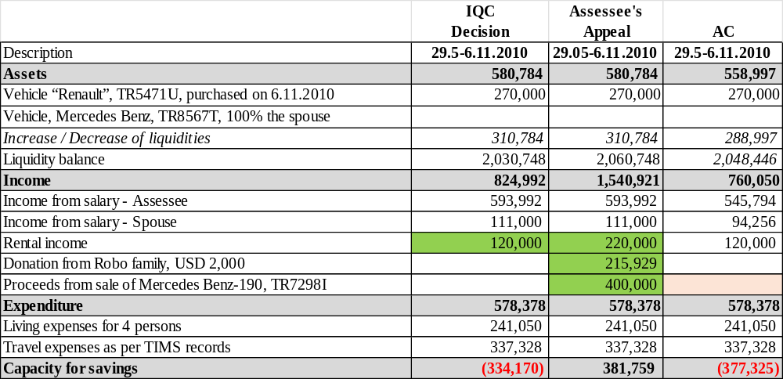
Note: Unlike the Commission, the AC’s analysis differs in terms of:
a) salary income of the assessee and her husband, as the IQC and assessee included the annual salary and the proportional amount for the months June–November 2010, whereas the AC included lower income (ALL 64,942) based on transfers to the assessee’s salary account at Credins Bank and to the spouse’s account at BKT; b) changes in liquidity, as the IQC and assessee included an increase of 310,784 ALL, while the AC has included ALL 288,997 (ALL 21,787 less); since the IQC and the assessee did not take into account the USD balance, which was USD 99.45 on 29.05.2010 and increased to USD 1,958 on 06.11.2010, whereas the AC converted the difference—i.e. the increase—applying the exchange rate of 2010.

However, with reference to the assessee’s claim that she had declared cash liquidity ALL 1,500,000, which she potentially used during the year to cover expenses or purchase assets and completed with annual income—and that cash liquidity cannot be calculated at a specific time during the year because it is declared only at year-end—it is observed that, referring the source disclosed in Vetting Declaration and in the Declaration Before Assuming Office on 18.11.2016, being “savings from salaries”, it appears to be founded the claim that the assessee could have temporarily used cash liquidity and replaced it at the end of 2010 (maintaining the same cash liquidity balance—this also in continuity with the analysis of the grounds of appeal discussed above regarding cash liquidity on 31.12.2010). The assessee declared increases in cash liquidity ALL 500,000 in 2008 and ALL 700,000 in 2009, i.e., a total of ALL 1,200,000, and according to the Commission’s analysis for 2008 and 2009, minimally had the capacity to save ALL 1,033,838, which could potentially have been used based also on the declared source for the creation of the Renault vehicle on 06.11.2010.

G. Regarding the overall financial analysis
The Commission concluded in the decision (page 50 of decision):

- “83. At the end of the re-evaluation process of the asset criterion, it was proven that the assessee, Brunilda Çarçiu, lacks lawful financial sources to justify the assets and expenses throughout the re-evaluation period, due to the negative balance in the amount of -4,824,260 ALL (of which 1,155,914 ALL pertains to the period outside the period she held office and 3,668,345 ALL pertains to the period during which she was in office).
- As regards the negative balance recorded during the period outside the time in office, and with reference to the standard applied in similar cases by both the Commission and the Chamber, the Commission, having regard to the factual circumstances and the amount of this balance, assessed that, proportionately, such negative balance could not penalize the assessee. This conclusion also took into account the fact that - although certain assets in the form of liquidities declared by the assessee’s spouse during this period and carried forward into the Vetting declaration were not justified by lawful sources - it was not established that such liquidities were invested in the creation of any assets during the time in office. Thus, pursuant to the criteria set out in Law no. 84/2016, letter “d” of paragraph 5 of Article 33/5/d of Law no. 84/2016 and Article D/3 of the Annex to the Constitution, and in accordance with the standard already established regarding the threshold of a penalizing negative balance for assessees, upon completion of the process, the Commission concluded that the negative balance of - 3,668,345 ALL during the period in office constitutes grounds for the imposition of the disciplinary sanction of assessee’s dismissal from office.

On the overall financial analysis for the period, the assessee claims in the appeal:
In her submissions regarding assets, the assessee requested that in the overall financial analysis be included the following:

- Consider investment for the construction of her share of the two-storey dwelling, in the amount of 1,727,494 ALL;
- include the father-in-law's income from the private shop activity in the village of Driza, Gramsh, in the amount of ALL 606.702;
- include the spouse’s income as an accounting expert in 1997;
- the reduction of living expenses for the period 1991-1999, due to the use of products from agricultural land;
- include rental income from the unit for the year 2013;
- include as lawful income the amount of 2,057.45 USD, wired on 20.10.2010 by the brother-in-law and nephew as gift to the account of the spouse;
- taking into consideration the amount of USD 1,000 donated by the father of the spouse in 2013;
- taking into consideration the sale price of the vehicle in 2010 according to the sales contract, i.e., 400,000 ALL and not 250,000 ALL, as concluded by the Commission;
- cash balance at the end of 2010 be ALL 1,500,000 as per arguments in the appeal.

As per documentation in the file:
- Regarding the overall financial analysis for the entire period up to 31.12.2003, and afterwards for the period 2004–2010 and 01.01–03.03.2011 [the time when was no longer legal assistant at the High Court, during which she had the obligation to declare], as well as for the period 18.11.2016–31.12.2016 [from 18.11.2016 onwards Inspector at the High Council of Justice Inspectorate, during which she made declarations], the Commission found in the results of investigation report a total negative balance of –9,222,340 ALL [consisting of –4,357,098 ALL for the analysis up to 31.12.2003, –57,009 ALL for 2008, –329,152 ALL for 2009, –1,211,116 ALL for 2010, and –3,267,965 ALL for the period 18.11–31.12.2016]. It is established, alike the Commission in its decision(methodology section), that the negative balance that resulted in the assessee’s analysis when not in office, namely 03.03.2011–18.11.2016 [–3,247,390 ALL], is included in the financial analysis for the period 18.11–31.12.2016, as the liquidity created during the period when assessee was not in office was carried over to the vetting declaration.
- After the assessee’s objections and after reviewing the financial analysis, the Commission established that the negative balance changed from 9,222,340 ALL to ALL 4,824,260. This negative balance shows the assessee lacked the capacities to create assets, liquidity and to cover her expenses for the following periods: i) 03.03.2011–18.11.2016, when assessee was not in office, a period which at the end of the process resulted in a negative balance of 1,155,914 ALL. This balance was carried over/reflected in the financial analysis of the entire re-evaluation period, because assets and liquidity created during this period were declared in the Vetting declaration; ii) 01.08.1991–03.03.2011 and 18.11.2016–31.12.2016, when assessee was in office, a period which at the end of the process resulted in a negative balance of ALL 3,668,345. The negative balance was reduced after the Commission took into account in the analysis some of the assessee’s claims, such as: i) income from the spouse’s mother’s pension; ii) income from the father-in-law’s private activity, as average of the minimum and maximum salary; iii) income from the sale of the apartment in Gramsh; iv) review living expenses up to 1999; v) redistribution of furnishing expenses as per assessee’s claims, in the analysis up to 31.12.2003 [addressed in ground of appeal “A” above]; vi) income from the lease of unit in Tirana for the years 2009, 2010, 2012, and 2016 (from 13.06.2016) [addressed in ground of appeal “C” above], as well as review the analysis on the period outside the time in office 03.03.2011–18.11.2016 [to be analysed below].
- The assessee brings in the appeal same claims as in her objections sent to Commission, claiming:
- Consider investment for the construction of her share of the dwelling, in the amount of 1,727,494 ALL and not ALL 3,000,000 – for the asset in Laprakë, Tiranë. Alike analysed in the report in ground of the appeal “A” above, it seems to be valid the Commission inclusion in the amount ALL 3,000,000 as declared by the assessee;
- The inclusion of the father-in-law's income from the private shop activity in the village of Driza, Gramsh, in the amount of ALL 606.702 - as addressed in the report under the ground of appeal “A” above, it seems to be valid the Commission inclusion in the amount of ALL 393,336 as the average of the minimum and maximum wages according to the relevant Council of Ministers’ decisions for the period up to 1997, since for the years 1998–1999 there is no information explaining the lack of supporting documentation;
- The inclusion of spouse’s income as an accounting expert in 1997 — as addressed in the report under the ground of appeal “A” above, is considered to be valid the Commission’s consideration. However, if considered the three appraisal reports of 1997 which assessee submitted to the Commission, and her calculations in the responses to Questionnaire No. 3, could be potentially be confirmed income in the amount of ALL 120,000; nevertheless, as with the other claimed income, the assessee has not proven the payment of tax obligations for this income.
- The reduction of living expenses for the period 1991-1999, due to the use of products from agricultural land, — as addressed in the report under the ground of appeal “A” above, the Commission seems to be right in calculating them at 30% of income, since a lower percentage would not make it credible that, for those years, the saving capacity would exceed 70% of income.
- The inclusion of rental income from the unit for the year 2013 — as addressed in the report under the ground of appeal “C” above, is considered fair the Commission stance to not include the rental income for 2013.
- Include as lawful income the amount of 2,057.45 USD, wired on 20.10.2010 by the brother-in-law and nephew as gift to the account of the spouse — as addressed in ground of appeal “F” above, is valid the non-consideration of the gift as income, even though the bank transfer to Raiffeisen Bank in 2010 by the spouse’s nephew is proven, because his financial capacity for that year is not substantiated by documentary evidence.
- Taking into consideration the amount of USD 1,000, gifted by the spouse’s father in 2012 — it is noted that the assessee declared this donation in the standard questionnaire. While in Questionnaire No. 2 informed that was donated as a sign of gratitude for taking care of him; he passed away on 28.04.2013 and that, due to father-child relations, no contract or written deed was concluded between them for the expression of will. The Commission did not include this donation as income, since the assessee has given some explanations, clarifying that this is a symbolic amount that her spouse's father had the capacity to save throughout his life but did not present any documentation to prove her claims, except for the documents that prove the pensions of her spouse's parents until year 2000. The Commission further reasoned that even in the case that the reference values ​​of the parents' pensions will be taken into account, they are minimum incomes which are even lower that living expenses per person according to the HIDAACI standard. For this reason, the amount of 1,000 USD was not considered as lawful income in the financial analysis of 2012. Given the state of the evidence, the Commission’s reasoning for not including the donation/income from the father appears to be well founded.
- Taking into consideration the sale price of the vehicle in 2010 according to the sales contract, i.e., 400,000 ALL and not 250,000 ALL as concluded by the Commission — as addressed in ground of appeal “E. Regarding the Mercedes-Benz vehicle purchased on 29.05.2010, seem founded to consider as income only the purchase price of the vehicle ALL 250,000 and not the sale price of ALL 400,000, insofar as assessee herself explained during the process that there was no specific reason for the higher sale price, other than that the buyer wanted to purchase this type of Mercedes, which had been well maintained, was in very good technical condition, and was useful for his activity, as stated by the buyer. As concluded by the Commission, this claim is considered declaratory and the sale of the vehicle for ALL 400,000 (approximately twice the purchase price and five years after the date of purchase) in 2010 is not justified.
- The cash balance at the end of 2010 be ALL 1,500,000 as per the arguments presented in the appeal. The assessee claims in the appeal that the Commission’s decision contains no reasoning regarding either the lawfulness of these balances or the arguments she presented, claiming that the cash balance in 2010 was in the amount of ALL 1,500,000, since the Commission did not dismiss her arguments. As addressed in ground of appeal “D. Regarding the cash balance at the end of 2010 and on 03.03.2011,” it appears to be grounded the assessee’s claim that the cash liquidity balance on 31.12.2010 was ALL 1,500,000.
- In view of the above, the total negative balance after the Commission revised the financial analysis resulted to – ALL 4,824,260 in total:
i) the negative balance of ALL 1,155,914 for the period 03.03.2011 – 18.11.2016, pertains to the period outside the period assessee held office. This balance was carried over/reflected in the financial analysis of the entire re-evaluation period because the assets and liquidity created during this period were declared in the Vetting declaration — to be addressed below.
ii) the negative balance of ALL 3,668,345 for the period 01.08.1991 – 03.03.2011 and 18.11.2016 – 31.12.2016, pertains to the period during which she was in office, as per narrative in the decision and after considering changes in the analysis, this negative balance results from: a) up to 2003 –2,480,493 ALL, instead of –4,357,098 ALL in the results of investigation; b) in 2008 –57,009 ALL, same as in the results of investigation; c)in 2009 –109,152 ALL, instead of –329,152 ALL in the results of investigation; d) in 2010 –1,001,116 ALL, instead of –1,211,116 ALL in the results of investigation; e) 18.11–31.12.2016, –1,176,489 ALL, instead of –3,267,965 ALL in the results of investigation.
The negative balances as per the grounds of appeal brough by the assessee are as follows:

- Analysis of the period up to 2003:
Based on the above, the Commission concluded a negative balance of –2,480,493 ALL up to 2003 instead of –4,357,098 ALL as per results of investigation. Whereas the assessee claims a positive balance of + 192,775 ALL. The assessee has included in the analysis she has prepared:
i) pension income of her husband’s mother in the amount of ALL 350,383, as per attestation enclosed to her objections which were taken into consideration by the Commission when revising the analysis in the decision;
ii) Income from the father-in-law’s private activity, as an average of the basic and maximum salary, in the amount of ALL 606,702, whereas the Commission in the revised analysis in the decision considered the amount of ALL 393,336 as per the Council of Ministers Decisions (DCM) for the period up to 1997, as there are no documents confirming the absence of data for 1998–1999;
iii) Income from the sale of the apartment in Gramsh, totalling ALL 1,700,000, instead of ALL 1,617,397 included in the results of the investigation results as corresponding share, included by the Commission in the revised analysis of the decision;
iv) reduction of living expenses up to 1999 – assessee claims ALL 2,142,066 arguing that, in addition to 30% of the income, 40% should be deducted due to agricultural and livestock production, while the Commission in the revised analysis of decision considered living expenses up to 1999 at 30% of the income;
v) redistribution of furnishing expenses as per the assessee’s claims, in the analysis of up to 31.12.2003 where assessee included the amount of ALL 300,000 (out of ALL 600,000 considered by the Commission in the results of the investigation) - a claim which the Commission considered in the revised analysis in the decision;
vi) Inclusion of the spouse’s income as an accounting expert in 2007, in the amount of ALL 630,000, which the Commission did not include in the revised analysis in the decision;
vii) Consideration of the investment for the construction of the attributable part of the two-story apartment in the amount of 1,727,494 lek, whereas the Commission considered the amount of ALL 3,000,000 lek declared by the assessee. Consider investment for the construction of her share of the dwelling, in the amount of 1,727,494 ALL and not 3,000,000 ALL as disclosed by assessee and considered by the Commission.

In view of the analysis under the ground of the appeal “A” above, on the two-story dwelling […] it appears to be founded the Commission’s analysis with a balance of –2,480,493 ALL, while the AC has found a negative balance of –2,572,540 ALL [ALL 92,047 more], mostly due to the calculation of living expenses as according to the AC’s standards for the period 1991–1993 could not be accumulated savings because of the social situation that dictated an extremely high inflation of ALL currency. While the Commission appears to have considered 30% of income for the entire period up to 1999, and similarly for the years 1994–1999. Meanwhile, living expenses up to May 2000, according to INSTAT, were calculated for six people, including the spouse’s parents, and after appointment in Tirana on 11.5.2000 for four people [totalling 531,000 ALL], and subsequently according to INSTAT for the year 2003. Had the income of spouse been considered ALL 120,000 in 1997 in three reports, although payment of taxes is not proven, the negative balance would respectively be reduced to –2,452,540 ALL.

Table no.5 – Comparative analysis, according to the Commission in the report on the results of investigation, according to the narrative in the decision, the assessee in the appeal until 2003 and the analysis at the AC.
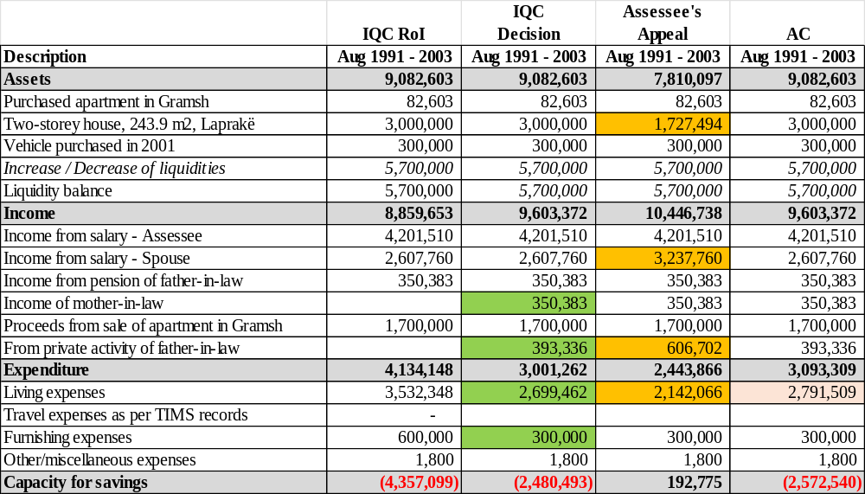

- Analysis for 2008:
With reference to the above, the Commission concluded a negative balance of –57,009 ALL in 2008, same as in the results of investigation. The assessee also reports a negative balance of –57,009 ALL. From the review of documents in the file and the Commission’s financial analysis, it is noted that this negative balance could be reduced to –27,009 ALL [ALL 30,000 less], as the assessee’s daughter, Esta, had at her account in Credins Bank at the end of year ALL 6,000, ALL 30,000 credited during 2008 with the description “SCHOLARSHIP FROM VASIL SHANTO SCHOOL”.

- Analysis for 2009:
With reference to the above, the Commission concluded a negative balance of –109,152 ALL in 2009 [ ALL 220,000 less] from –329,152 ALL as per results of the investigation. This, because according to the decision narrative, the Commission considered rental income for 2009 in the amount of ALL 220,000. The assessee also reports a negative balance of –109,152 ALL. From the review of documents in the file and the Commission’s financial analysis, it is noted that this negative balance could be reduced to –85,291 ALL [ ALL 23,862 less], because it is found that the assessee’s daughter, Esta, in her account at Credins Bank had a balance of ALL 30,000 credited during 2009 the amount of ALL 24,000 from the “VASIL SHANTO” school. While, there is a balance difference of 139 ALL due to the USD exchange rate: the AC considered the exchange rate as per BoA exchange rate of 31.12.2009, while the Commission used the average exchange rate of December 2009.

- Analysis for 2010:
With reference to the above, the Commission concluded a negative balance of –1,001,116 ALL in 2010 instead of –1,211,116 ALL in the results of the investigation [i.e., ALL 210,000 less], this because as per the decision’s reasoning, the Commission considered rental income for 2010 in the amount of 210,000 ALL. The assessee results with a positive balance of +94,813 ALL, as she claimed: a) rental income in the amount of ALL 240,000; b) donation from the nephew /Robo family in the amount of 2,057.45 USD (equivalent to 215,929 ALL), of which 1,958 USD was transferred to the assessee’s spouse’s account at Raiffeisen Bank;
c) increase in liquidity by 387,291 ALL less than the Commission where increase is 700,000 ALL, since, according to the ground of the appeal, it was considered that the cash liquidity at the end of 2010 was 1,500,000 ALL. From the review of documents in the file and the Commission’s financial analysis, it is noted that this negative balance could be lower, at –288,212 ALL [i.e., ALL 712,904 less], because: a) was taken into consideration the assessee’s claim that cash liquidity at the end of 2010 was 1.5 million ALL [analysed above under the ground of appeal “D”, on the cash balance at the end of 2010 and on 03.03.2011”], and there is also a difference in liquidity in bank of ALL 2,765 less; b)were taken into account rental income in the amount of 220,000 ALL [higher than the Commission’s 210,000 ALL, but less than the assessee’s claimed 240,000 ALL], i.e., 12 months of rent at 20,000 ALL/per month according to the lease agreement of 23.02.2010, covering the period 15.02.2010 – 15.02.2011, and 1 month from the 2009 lease agreement of 30.01.2009 for a one-year term, while the other elements in the analysis are the same as those of the Commission. Therefore, alike the Commission were not taken into consideration the assessee’s claims regarding: a) income from the spouse’s nephew, namely the donation of 2,000 USD or 215,929 ALL transferred to Raiffeisen Bank, since his income in the USA for that year was not justified; b) ALL 250,000 was considered as the sale value of the vehicle Benz TR 7298 I, and not 400,000 ALL as per the sales contract.

Table no.6 – Comparative analysis, according to the Commission in the report on the results of investigation, according to the narrative in the decision, the assessee in the appeal for the year 2010 and the analysis at the AC.
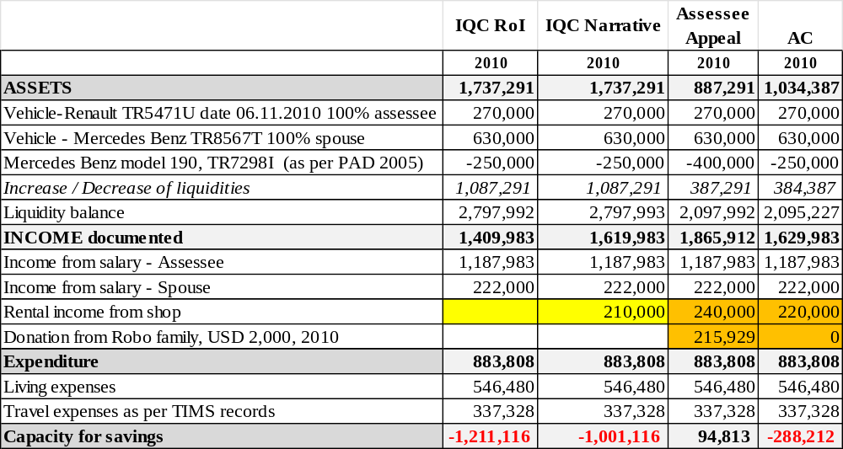

- Analysis 18.11.2016 – 31.12.2016:
With reference to the above, the Commission concluded a negative balance of –– 1.176.489 ALL for the period 18.11.2016-31.12.2016 instead of –3.267.965 ALL as per the results of the investigation [i.e., ALL 2.091.476 less], this because as per the decision’s reasoning, the Commission considered the negative balance of the time when assessee was not in office as “adjustment” of expenses in the amount 3.247.390 ALL in the results of the investigation and ALL 1.155.914 as per the decision’s analysis for the period 03.03.2011-18.11.2016, and on the other hand considered “adjustment” of income in the amount of ALL 8.181.356 [of increase of liquidity during the time assessee was not in office]. The Commission stated in decision [para.81] that “[…] i) 03.03.2011–18.11.2016, when assessee was not in office, a period which at the end of the process resulted in a negative balance of 1,155,914 ALL. This balance was carried over/reflected in the financial analysis of the entire re-evaluation period, because assets and liquidity created during this period were declared in the Vetting declaration; and in the methodology section [page 49] “Part of the liquidity that was declared in the vetting declaration was created during a period when the assessee was not in office, to be vetted. However, the source of their creation was analyzed and the result obtained from this verification (Financial analysis for the period not in office) has been carried over to the period in office, thus affecting the total result of the assessee”.
It is noted that for the period 18.11.2016-31.12.2016 the assessee has not presented an analysis (table form), but has presented an analysis for the period when not in office 03.03.2011-18.11.20116 which will be analysed below.
From the review of documents in the file and the Commission’s financial analysis, the AC notes that this negative balance of the period under analysis 18.11.2016-31.12.2016 is positive [+ 109,653 ALL], as it is considered that the elements in the analysis considered by the Commission as "adjustment" which under Income is the difference in liquidity and in Expenses is the negative balance of the period outside the time in office 03.01.2011-18.11.2016, should not be included in the analysis [this analysis will be carried out separately] in order to see the analysis of the period without other elements; While the other elements in the analysis compared to the Commission are the same, except, a) income from Andja's salary for the period 18.11.2016-31.12.2016 according to the ABI Bank statement, a total value of 121,720 lek was credited on 25.11.2016, 6.12.2016 and 29.12.2016 [higher than the Commission which considered ALL 60,860] as the Commission seems to have considered the proportion of the credited income;
b) increase of liquidity in bank since no changes in cash were declared for the period, was considered at the AC at ALL 111,928 while the Commission considered increase 181,296 ALL[i.e. less than ALL 69,368] this is the result of a combination of: i) The Commission considered the ALL equivalents of the USD and Euro accounts balance as total balance at the exchange rate of the year, while the exchange rate changes have given effect to an increase of liquidity, while the AC considered the practice that only the increase of liquidity during the year was converted at the exchange rate of the year, and ii) The Commission did not consider the balance in the EUR account of the assessee's spouse at Raiffeisen Bank, meanwhile, according to the statement, it appears that on 18.11.2016 he had a balance of 501 euros which he later withdrew on 25.11.2016.

Table no.7 – Comparative analysis according to the Commission in the report on the results of investigation, according to the narrative in the decision, for the period 18.11.2016 – 31.12.2016 and the analysis at the AC.
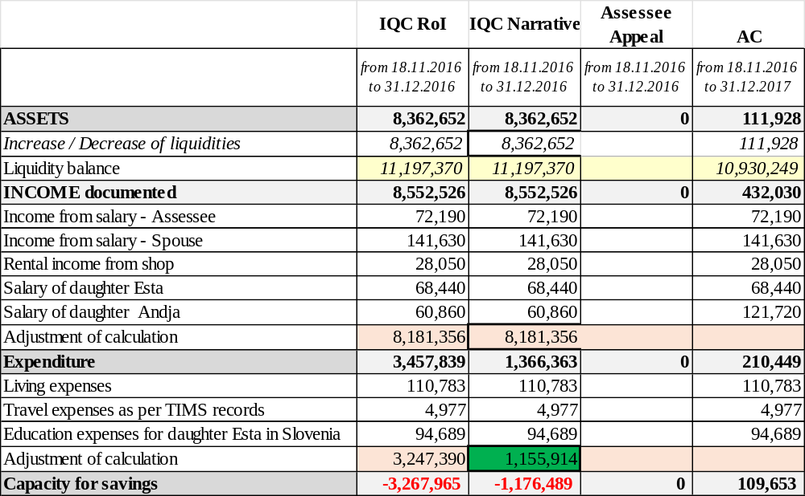

- Analysis 03.03.2011 – 18.11.2016, assessee was not in office:
With reference to the above, the Commission concluded for the period 03.03.2011–18.11.2016, when assessee was not in office, a negative balance of 1,155,914 ALL, instead of –3,247,390 ALL as per the results of the investigation. Meanwhile, in the table of the analysis in the appeal [page 56], the assessee claims a negative balance of –442,429 ALL.
From the review of documents in the file and the Commission’s financial analysis, the AC notes that the negative balance for the period when the assessee was not in office (03.03.2011–18.11.2016) is –2,325,800 ALL [which is 1,169,886 ALL more compared to the Commission], as a difference from:
- Income in the amount of 12,869,193 ALL less than the Commission that included them at 16,051 ALL and less than assessee’s calculation at 391,341 ALL, as a combination of:
  - less income of assessee in the amount of ALL 41,662 compared to the Commission and the assessee, since the AC calculated incomes as per bank statements from Raiffeisen Bank, whereas the Commission and the assessee appear to have applied a proportionate calculation for the period;
  - less income for the assessee’s spouse in the amount of 12,580 ALL compared to the Commission and the assessee, since the AC calculated the amounts as per account statement from BKT, Intesa Sanpaolo, Alpha Bank and Raiffeisen Bank, whereas the Commission and the assessee appear to have applied a proportional calculation for the period;
  - rental income, same as Commission, in the amount of 310,125 ALL less than that claimed by the assessee. The Commission analyses in its decision [para. 74, page 43] to have considered rental income of 2012 and five months of 2016, totalling 310,125 ALL. The assessee claims a net amount of 484,125 ALL, or a total of 570,750 ALL, consisting of 240,000 ALL in 2012, 240,000 ALL in 2013, and 90,750 ALL for 5.5 months in 2016. As dealt with under the appeal ground “C” above, is considered valid the Commission’s approach in the analysis;
  - Income from bank interests in the amount 430,677 ALL more than the Commission’s calculation of 133,631 ALL. It is observed that the Commission (and the assessee likewise) failed to include—apparently due to an oversight, as reflected in the Excel financial analysis—the interest from Treasury Bills in 2016, which is also confirmed by the attestation enclosed to the standard questionnaire and Raiffeisen Bank transactions dated 9.5.2016 and 9.11.2016.
  - The donation of USD 7,000 from the nephew (the Robo family) to the assessee’s spouse was considered in the analysis at the equivalent of 745,990 ALL, as calculated by the Commission based on the average exchange rate for December 2012, and not as calculated by the assessee, who converted it to 825,560 ALL.
  - Income of the daughter, Esta Çarçiu, amounting to 683,022 ALL less than that calculated by the Commission and the assessee being 95,440 ALL, since the Commission and assessee relied on salary confirmation submitted by the assessee, whereas the AC relied on bank transactions at Intesa Sanpaolo Bank up to 18.11.2016, which show transfers totalling 683,022 ALL.
  - Income of the daughter, Andija Çarçiu, in the amount of 121,720 ALL as per assessee’s analysis, were not included in the analysis like the Commission, because this income was deposited in ABI Bank after 18.11.2016 and was therefore included in the AC’s analysis for the period 18.11.2016–31.12.2016.
- Expenses ALL 5,978,231, more than 685,896 ALL calculated by the Commission. The largest difference arises because the Commission, due to an apparent oversight, miscalculated expenses for the period 01.01.2016–18.11.2016 by applying HIDAACI expenses based on INSTAT data, but incorrectly calculated this period as 43 days in 2016 instead of 10 months and 18 days. The AC calculated expenses for 2016 as follows: for 9 months for a family of 4 people, and for October and the first 18 days of November family of 3 people, since the daughter went to study in Slovenia, and the corresponding expenses were calculated accordingly.
- Assets in the amount ALL 9,216,762 ALL, more than ALL 467,938 calculated by the Commission, and 764,939 ALL calculated by the assessee, as a combination of: less liquidity in bank being 232,062 ALL, since on 18.11.2016 the AC calculated 9,918,321 ALL (or ALL 197,753 less than the Commission), mainly due to exchange rate differences, whereas on 03.03.2011 the AC calculated 669,026 ALL (or 34,308 ALL more than the Commission) and cash liquidity showing a difference of 700,000 ALL, since the cash balance at the end of 2010 was considered to be 1,500,000 ALL as claimed by the assessee, compared to the Commission’s calculation being 2.2 million ALL.
As regards the value of the construction plot, it is considered 567,467 ALL same as Commission, based on the documents, namely payment slips of 949,868 ALL made on 17.12.2014 and payments made with privatization bonds in the amount of 1,320,000 ALL - one quarter of which was considered as an expense of the assessee and the spouse. On the other hand, the portion contributed through privatization bonds by the assessee’s spouse, amounting to 1,320,000 ALL, i.e. one quarter equal to 330,000 ALL, was also considered in the analysis as income from privatization bonds.

Table no.8 – Comparative analysis of the Commission in the report on the results of investigation, according to the narrative in the decision, the assessee in the appeal for the period outside term in office 03.03.2011 - 18.11.2016 and the analysis at the AC.

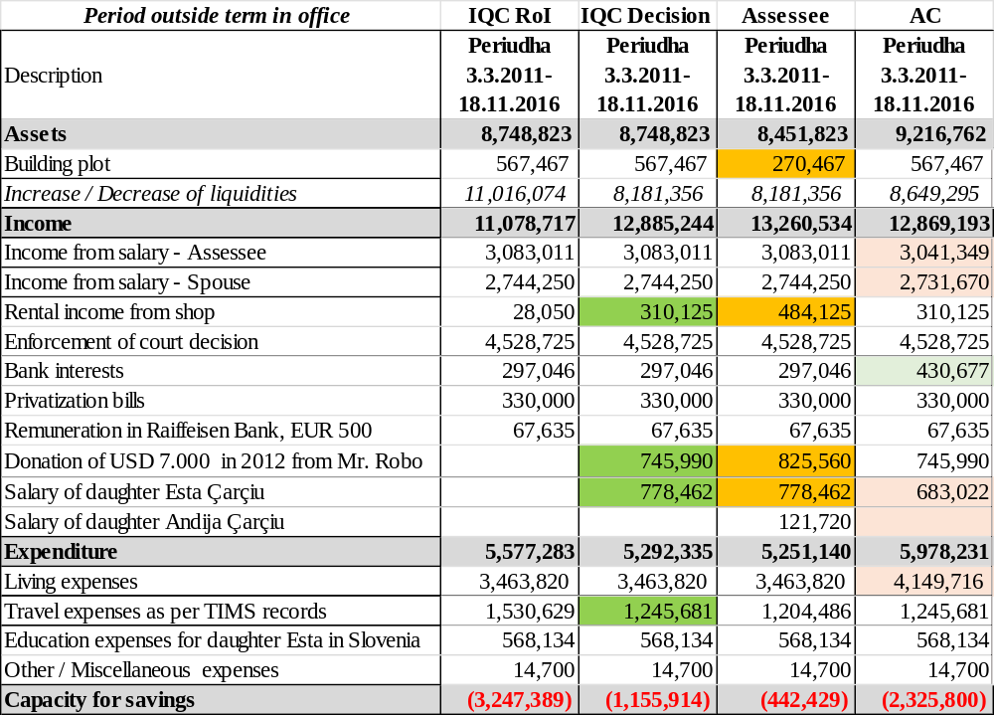
Thus, the Commission concluded a difference of ALL –4,824,260, consisting of:
i) ALL –1,155,914 for the period outside the time in office 03.03.2011 to 18.11.2016; and
ii) ALL –3,668,345 for the period when in office. While from the review of the grounds of appeal and as per certain changes in the elements of the AC analysis, it results a total negative balance of ALL –2,973,052 (ALL 695,293 less than the Commission’s analysis) for the period when in office up to 03.03.2011 and 18.11.2016- 31.12.2016, and for the period from 03.03.2011- 18.11.2016, during which the assessee was not in office, a difference of ALL –2,325,800 (ALL 1,169,886 more than the Commission’s analysis).

These are presented comparatively in Table No. 9 below.

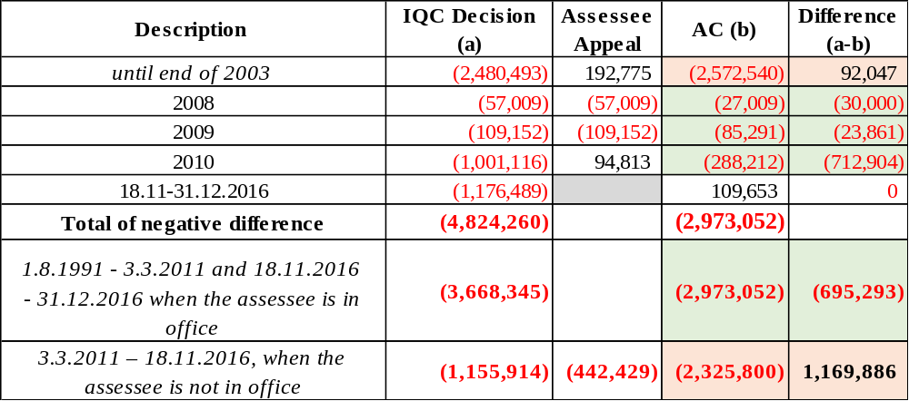

The assessee in the appeal states “amendment of decision no. 543”, the decision number is apparently a lapsus, as the number of the IQC decision on the assessee is 542 dated 20.06.2022.
See replies to questionnaire no.2 and attached documents in the file of IQC.
Except that Skënder Çarçiu has in total two apartments measuring 125.76 m², i.e., 2 m² more than the spouse of the assessee and the other brother and their father.
The Commission considered as referred to in the investigation results: "according to the assessee's statements, the apartment was built as a frame structure during the years late 1996, 1997 and 1998, a phase which is estimated as 60% of the construction volume; the construction continued throughout 1999 (when the assessee's husband came to Tirana) and 2000 and the remaining part 40% was divided equally 20%, for each of the years 1999 and 2000. Thus, the investment amount of 3 million ALL was divided analogously according to the volume of works.”.
Period eventually considered by the IQC as the period of house construction, years 1997-2000.
HIDAACI sent to the IQC by letter prot. no. 2673/2, dated 28.04.2020.
In her submissions, page no. 3, the assessee stated “The value of 3.000.000 was first declared in the PAD of 2003, in the amount of ALL 3,000,000, value which in my (and my husband’s) opinion, represents the market value of this house in 2003.”.
https://NHE.gov.al/kostot-e-ndertimit-viti-2003/
Decision no.35/2022 (JR) dated 22.09.2022, on assessee Entela Shedula, para. 49.
“62 Refer to law no. 7928, dated 27.4.1995, “On VAT”, as amended, Article 1, para. 2/a, according to which Value Added Tax (VAT) is paid: a. on all taxable supplies of goods and services made against remuneration by a taxable person as part of his economic activity in the territory of the Republic of Albania. “.
Letters of the NHE addressed to the AC, prot. no. 945/5, dated 11.03.2019; NHE addressed to the AC, prot. no..1188/8 prot, dated 13.10.2021; NHE addressed to the AC, prot. no. 1188/10 dated 21.10.2021.
As a total of the reserve fund of 3.97% and the share of planned profit as part of Overall Expenses & Projected Profit.
As a total: for 1993, for 12 months, multiplied by average salary of ALL 3.278 (minimum salary of ALL 1.639, and maximum of ALL 4.917) = 39.336 ALL, addition for 1994 for 12 months multiplied by average salary of ALL 5.120 ALL (maximum salary of ALL 2.560 ALL and maximum of 7.680 ALL) = 61.440 ALL, addition for 1995 for 12 months multiplied by average salary of ALL 6.360 ALL (and maximum of ALL 3.180 ALL and maximum of 9.540 ALL) = 76.320 ALL, addition for 1996 for 12 months multiplied by average salary of ALL 8.200 ALL (maximum salary of ALL 4.100 ALL and maximum of 12.300 ALL) = 98.400 ALL, addition for 1997 for 12 months multiplied by average salary of ALL 9.820 ALL (maximum salary of ALL 4.910 ALL and maximum of 14.730 ALL) = 117.840 ALL, total of ALL 393.336.
The calculations of the assessee are as follows: Water Supply Entity, 50 hours*1000 ALL/hour =50.000 ALL; Shpresa company, 60 hours *1000 ALL/ hour =60.000 ALL; Autostar company me 30 hours *1000 ALL/ hour =30.000 ALL; Kosturi company me 30 company *1000 ALL/ hour =30.000 ALL; Uzina Mekanike me 70 hours *1000 ALL/ hour =70.000 ALL; thus, in total 50.000 + 60.000+ 30.000 + 30.000 + 70.000 = ALL 240.000.
According to this order, in Article 94, paragraph 1, there is an exception to the general rule, according to which: "the incompatibility of the function of an authorized accounting expert with the position of an employee shall not apply to prominent employees of the state administration.".
As a total: i) for the entity “Shpresa” expert report dated 30.03.1997, for 60 working hours, multiplied by 1.000 ALL/hour results in 60.000 ALL; ii) for the entity “Auto-Star” expert report dated 3.10.1997, for 30 working hours, multiplied by 1.000 ALL/hour results in 30.000 ALL; iii) for the entity “Kosturi” expert report undated, for 30 working hours, multiplied by 1.000 ALL/hour results in 30.000 ALL.
“21.42 The reassessment bodies should certainly carry out a logical and reasonable analysis for the calculation of these expenses in cases where other elements are combined, taking into account in any case that the rate of 66% of expenses in relation to employment income before 2000 would only make sense when considering average public sector incomes of approximately USD 800 per year, according to the Bank of Albania reference, and evaluating this orientation towards determining a logical analysis and not as a mandatory legal reference for implementation..”
Total income of ALL 260.529.
Refer to: In the periodic report of the Bank of Albania for 1995, regarding the country's economy for the last 5 years, it is stated that: “[...] In September 1991, the official exchange rate was devalued, fixing the US dollar at 25 ALL/USD from 10 ALL/USD at the beginning of 1991. Then, the implementation of the flexible exchange rate regime devalued the local currency ALL by 220%, and at the end of 1992 it closed with an exchange rate of 98.88 ALL/USD. The successive devaluations in 1991 were followed by the complete liberalization of the exchange rate of the lek in July 1992. The years 1992 and 1993 also marked the transition to a large-scale liberalization of the prices of goods and services, while still maintaining a limited basket of consumer goods with prices controlled by the state. This period also marks the liberalization of foreign trade, abolishing the state monopoly on foreign trade and implementing free import and export regimes. The exchange rate and the prices of goods and services were placed under the rule of free market forces.: https://www.bankofalbania.org/Botime/Botime_Periodike/Raporti_Vjetor/Raporti_Vjetor_1995.html
As total living expenses: for the period up to 1993, no savings were calculated: from 1994 to 1999 for the total income of ALL 2,912,039 at 30% or ALL 873,612, and subsequently according to INSTAT for the year 2000, of ALL 531,000 for 5.5 months for 6 people and subsequently for 4 people after receiving the appointment in Tirana, for the year 2001 375,456 ALL for a family of 4 people as for the year 2002 since there is no data, for the year 2002 for a family of 4 people of ALL 375,456 and for the year 2003, ALL 375,456 for a family of 4 people.
Total income of ALL 260.529.
Refer to: In the periodic report of the Bank of Albania for 1995, regarding the country's economy for the last 5 years, it is stated that: “[...] In September 1991, the official exchange rate was devalued, fixing the US dollar at 25 ALL/USD from 10 ALL/USD at the beginning of 1991. Then, the implementation of the flexible exchange rate regime devalued the local currency ALL by 220%, and at the end of 1992 it closed with an exchange rate of 98.88 ALL/USD. The successive devaluations in 1991 were followed by the complete liberalization of the exchange rate of the lek in July 1992. The years 1992 and 1993 also marked the transition to a large-scale liberalization of the prices of goods and services, while still maintaining a limited basket of consumer goods with prices controlled by the state. This period also marks the liberalization of foreign trade, abolishing the state monopoly on foreign trade and implementing free import and export regimes. The exchange rate and the prices of goods and services were placed under the rule of free market forces: https://www.bankofalbania.org/Botime/Botime_Periodike/Raporti_Vjetor/Raporti_Vjetor_1995.html
According to the explanations in questionnaire no. 2, has explain ed that the contract rep. no. 904, col. no. .., dated 23.02.2010, with the entity Gazmir Çera lasted for 1 year, in the amount of 240,000. The facility was rented out for internet café activity. .
According to the explanations in questionnaire no.2, it has been explained that Contract no.1344 rep, no.654 col, dated 13.06.2016, is in force currently without interruption. The facility is rented out for dry cleaning activity. Attached are the documents with number 3.3.
As a total of rental income for 11 months of 2009 at 20,000 ALL, amount of 220,000 ALL, for 2010 of 240,000 ALL, for 2 months of 2011 of 40,000 ALL, for 2012 of 240,000 ALL and for the income claimed for 2013 but for which there is no contract of 240,000 ALL.
The assessee has attached the Confirmation of submission of the declaration of 2003 to HIDAACI prot. no. Extra prot, dated 28.03.2007, attached to the replies to questionnaire no.3.
It is noted from the statements of the assessee’s spouse account at Raiffeisen Bank that on 20.10.2010 an amount of USD 1,958 was credited from the account of citizens Kristaq or Damian Robo, increasing the account balance to USD 2,057.45 as of 20.10.2010”.
IQC and assessee considered the proportional amount for 6 months ALL 593,992, while according to the account statement from Credins Bank, 545,794 ALL were transferred; for the husband, the IQC and assessee included the proportional amount for 6 months of 11,000 ALL, while according to the account statement from BKT, ALL 94,256 were transferred.
In 2008, from the declared cash savings in the amount of ALL 500,000, had the capacity to save ALL 442,991 (as the IQC found a negative balance of –57,009 ALL for the year), and in 2009, from the declared cash savings of ALL 700,000, had the capacity to save ALL 590,848 (as the IQC found a negative balance of –109,152 ALL for the year).
[...]Part of the liquidity that was declared in the vetting declaration was created during a period when the assessee was not in office, to be vetted. However, the source of their creation was analyzed and the result obtained from this verification (Financial analysis for the period not in office) has been carried over to the period in office, thus affecting the total result of the assessee”.
Total of: i) for the entity “Shpresa,” the appraisal report of 30.03.1997 (60 hours of work * 1,000 ALL/per hour = 60,000 ALL); ii) for the entity “Auto-Star,” the report dated 03.10.1997, (30 hours of work * 1,000 ALL/ per hour = 30,000 ALL); iii) for the entity “Kosturi,” the expert report (no date), (30 hours of work *1,000 ALL/ per hour = 30,000 ALL.
As a difference of total: a) Income in the amount of ALL 9,603,372 as calculated by the Commission, less than ALL 843,336 calculated by the assessee [since the spouse’s income from 1997 in the amount of ALL 630,000 was not considered, more income from the father-in-law’s private activity in the amount of ALL 213,366]; b) Expenses in the amount of ALL 3,093,309, higher than those calculated by the Commission being ALL 92,047 due to the recalculation of expenses, as until 1993 no savings were generated, while the assessee claims lower expenses in the amount of ALL 557,396; c) Assets in the amount of ALL 9,082,603 as calculated by the Commission, while the assessee claims asset to be ALL 1,272,506 due to the calculation of a lower value for the construction of a two-storey dwelling”
Total income ALL 260.529.
See: The periodic report of the Bank of Albania for the year 1995, regarding the country’s economy in the last five years, according to which: ‘[…] In September 1991, the official exchange rate was devalued and US dollar changed to 25 ALL/USD instead of 10 ALL/USD that was at the beginning of 1991. Subsequently, the application of a flexible exchange rate regime led to a devaluation of the domestic currency (the lek) by 220%, and by the end of 1992 it closed at an exchange rate of 98.88 ALL/USD. The successive devaluations in 1991 were followed by the full liberalization of the lek’s foreign exchange rate in July 1992.The years 1992 and 1993 also marked the transition to broad liberalization of the prices of goods and services, while still maintaining a limited basket of consumer goods with prices controlled by the state. This period also marks the liberalization of foreign trade, through the removal of the state monopoly over foreign trade and the implementation of free import and export regimes. The exchange rate and the prices of goods and services were placed under the influence of free market forces.’” https://www.bankofalbania.org/Botime/Botime_Periodike/Raporti_Vjetor/Raporti_Vjetor_1995.html
As a difference of total: a) Income in the amount of ALL 1,629,983 more than that calculated by the Commission, plus ALL 10,000 from rent, and less than ALL 235,929 claimed by assessee ALL 235,929 [as the income from the spouse’s nephew was not considered, namely a donation of USD 2,000 or ALL 215,929, since his income in the USA was not proven, and lower rental income to ALL 20,000]; b) Expenses in the amount of ALL 883,808, the same as calculated by both the Commission and the assessee; c) Assets to ALL 1,034,387, less than that calculated by the Commission [ALL 702,904, as it was considered that the cash liquidity at the end of 2010, as claimed by the assessee, amounted to ALL 1,500,000, as well as due to changes in bank liquidity mainly resulting from the exchange rate], while the assessee claims less assets at ALL 887,291 due to the calculation of the sale value of the vehicle Benz TR 7298 I at ALL 400,000 and not, as calculated by the Commission and the AC, at the purchase value of ALL 250,000.”
This, because the Commission considered the lek equivalents of the USD account balances by applying the annual exchange rate to the total balance, whereas exchange rate fluctuations resulted in a higher increase in liquidity, while the AC considered the practice that only the increase of liquidity during the year was converted at the exchange rate of the year”.
The difference between “Increase / decrease of liquidity” in the amount of ALL 8,362,652 and the “adjustment” in Incomes of ALL 8,181,356, which represents the increase in liquidities outside the tine in office 03.03.2011 - 18.11.2016.
It is noted that the exchange rate in 2011 was EUR = ALL 138.93, while in 2016 it was EUR = ALL 135.23, and for the USD respectively USD = ALL 107.54 and USD = ALL 128.17.”
As a combination of: i) The Commission considered the ALL equivalents of the USD and Euro accounts balance as total balance at the exchange rate of the year, while the exchange rate changes have given effect to an increase of liquidity, while the AC considered the practice that only the increase of liquidity during the year was converted at the exchange rate of the year, and ii) The Commission did not consider the balance in the EUR account of the assessee's spouse at Raiffeisen Bank, meanwhile, according to the statement, it appears that on 18.11.2016 he had a balance of 501 euros which he later withdrew on 25.11.2016.
As a combination of: i) The Commission considered the ALL equivalents of the USD and Euro accounts balance as total balance at the exchange rate of the year, while the exchange rate changes have given effect to an increase of liquidity, while the AC considered the practice that only the increase of liquidity during the year was converted at the exchange rate of the year, and ii) The Commission did not consider the balance in the EUR account of the assessee's spouse at Alpha Bank, meanwhile, according to the statement, it appears that on 2.2.2011 was credited EUR 270 from Journalists Union and transaction happened afterwards in April 2011.

